Time signatures and layering time signatures. 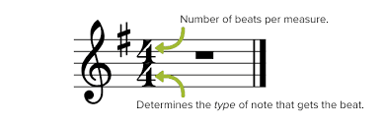
Polyrhythm is the rhythms that are the same but can be layered over each other.
This week we are layering the time signature 6/8 over ¾. This gives the rhythm a different PULSE that can be called Syncopation.
The syncopated rhythms are usually easy to sing, since they often match speech better than straight rhythms.
Listen to the song and try and count out both ¾ and 6/8/ rhythms. 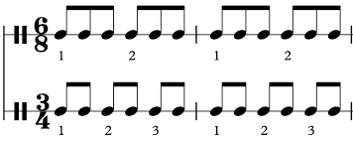

LOVER – TAYLOR SWIFT>

We could leave the Christmas lights up 'til January
And this is our place, we make the rules
And there's a dazzling haze, a mysterious way about you dear
Have I known you 20 seconds or 20 years?
Can I go where you go?
Can we always be this close forever and ever?
And ah, take me out, and take me home
You're my, my, my, my
Lover
We could let our friends crash in the living room
This is our place, we make the call
And I'm highly suspicious that everyone who sees you wants you
I've loved you three summers now, honey, but I want 'em all
Can I go where you go?
Can we always be this close forever and ever?
And ah, take me out, and take me home (forever and ever)
You're my, my, my, my
Lover

Ladies and gentlemen, will you please stand?
With every guitar string scar on my hand
I take this magnetic force of a man to be my lover
My heart's been borrowed and yours has been blue
All's well that ends well to end up with you
Swear to be overdramatic and true to my lover
And you'll save all your dirtiest jokes for me
And at every table, I'll save you a seat, lover
Can I go where you go?
Can we always be this close forever and ever?
And ah, take me out, and take me home (forever and ever)
You're my, my, my, my
Oh, you're my, my, my, my
Darling, you're my, my, my, my
Lover

