PLAYING IN A DIFFICULT KEY.
What happens when you are asked to play in a key you are not familiar with?
Do keys like Bb and Ab leave you confused about what other chords to play next?
Using the knowledge, we have gained in familiar keys earlier in the series we are going to use this to gain confidence in a key rarely used by guitarists and pianists.
Using the cycle of 5th that you should be growing familiar with we are going to work out the 1,4,5 and relative minor in the key of Ab.

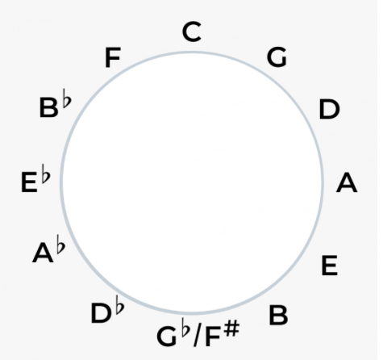

PERFECT – ED SHEERAN
Ab. Fm
I found a love for me
Db Eb
Oh darling, just dive right in and follow my lead
Ab. Fm
Well, I found a girl, beautiful and sweet
Db Eb
Oh, I never knew you were the someone waiting for me
Ab.
'Cause we were just kids when we fell in love
Fm
Not knowing what it was
Db Ab Eb
I will not give you up this time
Ab. Fm
But darling, just kiss me slow, your heart is all I own
Db Eb
And in your eyes, you're holding mine
Fm. Db. Ab Eb Fm
Baby, I'm dancing in the dark with you between my arms
Db. Ab Eb Fm
Barefoot on the grass, listening to our favourite song
Db. Ab Eb Fm
When you said you looked a mess, I whispered underneath my breath
Db. Ab Eb Ab
But you heard it, darling, you look perfect tonight
Ab. Fm
Well I found a woman, stronger than anyone I know
Db Eb
She shares my dreams, I hope that someday I'll share her home
Ab. Fm
I found a love, to carry more than just my secrets
Db Eb
To carry love, to carry children of our own
Ab.
We are still kids, but we're so in love
Fm
Fighting against all odds
Db Ab Eb
I know we'll be alright this time
Ab.
Darling, just hold my hand
Fm
Be my girl, I'll be your man
Db Ab Eb
I see my future in your eyes

Fm. Db. Ab Eb Fm
Baby, I'm dancing in the dark, with you between my arms

Db. Ab Eb Fm
Barefoot on the grass, listening to our favorite song
Db. Ab Eb
When I saw you in that dress, looking so beautiful
Fm. Db. Ab Eb Ab
I don't deserve this, darling, you look perfect tonight
Fm. Db. Ab Eb Fm
Baby, I'm dancing in the dark, with you between my arms
Db. Ab Eb Fm
Barefoot on the grass, listening to our favorite song
Db. Ab
I have faith in what I see
Eb Fm. Db.
Now I know I have met an angel in person
Ab Eb Ab
And she looks perfect
Fm. Db
I don't deserve this
Ab Eb Ab
You look perfect tonight

