National Panel for CSPR’s
Report Sept 2021 highlights:
“insufficient attention to men means that support for them to be active and engaged is limited””

Practitioner Learning Brief
Child J – November 2021
Full Report at: https://bit.ly/310GtbN

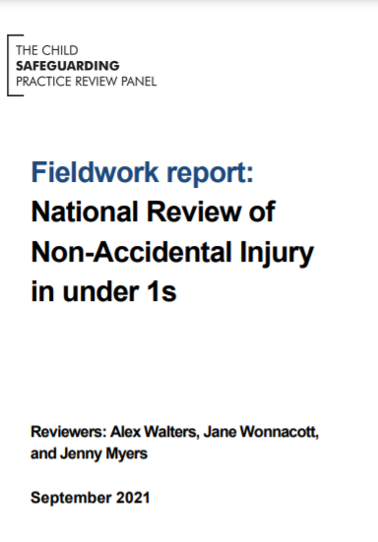
Background summary
Child J, who was seriously harmed, aged 3 months, due to non-accidental injury
Finding of Fact indicated injuries caused while in father’s care
Parents were young and vulnerable, and both had engagement with Social Care when young
Mother spent periods living with both maternal grandparents who were separated (history of alcohol misuse and domestic abuse in that relationship)
There was an allegation of Domestic Abuse and rape in one of mother’s previous relationships
Father had a history of anti-social behaviour from primary school and disengaged with secondary education. He was described as unafraid of confrontation and both he and his siblings were subject of referrals to Social Care
At the age of 18 mother secured supported living housing but spent little time there preferring to live with father in a house of male occupancy
Mother presented as competent young mother throughout all interactions with agencies
At the 6-8-week check baby had a small mark on upper arm
Baby did not always sleep in a Moses basket. On the evening before presentation at hospital, baby had spent time with father sleeping in a bouncy chair while mother was out with friends
Parents have since separated and baby doing well in care of foster parents

What are we worried about?
- Care of young babies and injuries
- How agencies worked together to support vulnerable young parents
- Insufficient focus on fathers / males
- Prebirth Assessments for all babies that need them
- Underestimation of the impact of parents’ youth, childhood and family circumstances because of the way they presented
- Safer Sleep and Bruising in Immobile Babies

Professional Curiosity
“it is hard for families to reach out therefore as professionals you need to reach in”

How do things look today?
Housing Needs Assessments for 16/17-year olds
Early Help Offer to expectant first-time parents and staff have attended briefing session
Full Histories are included in assessments (including periods out of area)
Strengthened handover from Midwife to Health Visitor
GP Risk Assessment and Support for Young Parents
Assurance from multi-agency partners around inclusion and involvement of males
Introduction of Fathers Only Baby sessions and Young Women’s Baby Sessions across health
Delivery of Bruising in Babies and Safer Sleep Briefing Sessions to multi-agency partners

Good Practice
Referral from Ambulance Service to Social Care after noticing the bruising
Routine enquiries around Domestic Abuse with mother and good support from YPVA
GP records noting the names of any males present
Work with Pregnancy Options Advisor
Social Workers forming good relationships with mother
Supported living keeping housing place open for mother

How do things look today?
Immediate Action by STSCAP: Delivery of Early Help, Bruising in Babies (when to be suspicious) and Safer Sleep Briefing Sessions to multi-agency partners
Improved Early Help Offer to expectant first-time parents
Housing Needs Assessments for 16/17-year olds
Full Histories are included in assessments (including periods out of area)
Strengthened handover from Midwife to Health Visitor
GP Risk Assessment and Support for Young Parents
Assurance from multi-agency partners around inclusion and involvement of males
Introduction of Fathers Only Baby sessions and Young Women’s Baby Sessions across health

Good Practice
Referral from Ambulance Service to Social Care after noticing the bruising
Routine enquiries around Domestic Abuse with mother and good support from YPVA
GP records noting the names of any males’ present
Work with Pregnancy Options Advisor
Social Workers forming good relationships with mother
Supported living keeping housing place open for mother

Bruising in non-mobile babies, children and young people
https://www.proceduresonline.com/nesubregion/files/southtyne_bruising.pdf

Professional Curiosity
“it is hard for families to reach out therefore as professionals you need to reach in”

Information of Relevance
National Panel Reports:
- The Myth of Invisible Men https://bit.ly/3nPD3Sj

- Out of Routine https://bit.ly/3cKB77t

- Reviewed South Tyneside Bruising in Non-Mobile Babies, Children and Young People Pathway

- STSCAP Multi-Agency Training https://bit.ly/3l821dI

- Safer Sleep https://bit.ly/3xo2M7J

Recommendations
Improve arrangements to engage vulnerable young parents – especially males, keeping fathers as well as mothers in mind during pregnancy and early childhood
Pre-Birth assessments to be completed for all that need them and with consent shared across multi agencies
Ensure assessments are informed by historical information (including out of area) and explore the meaning of “good support” from extended family members
Be fully informed of all parental vulnerabilities and risk factors when exercising professional judgement about new marks on babies

