English Activity – Grammar and Punctuation
The Department for Education and the government have established Key Themes as specific topics that aim to enrich your learning by improving your wider skills and understanding above and beyond the course you are taking. Skills South Tyneside and your training provider want you to gain the most from your programme of learning and these activities will help to embed those Key Themes. The Key Themes are:
M-  Maths | E-  English | ILT- Information Learning Technology | EDI- Equality, Diversity Inclusion | S-  Safeguarding | P- Prevent | C-  Climate | HS- Health and Safety | BV-  British Values
What is Grammar?
Grammar refers to the way we put words together in sentences and paragraphs to form meaning. It’s the fundamental structure of language, describing what words should go where and why.

One of the most basic grammar rules describes the building blocks of a sentence: every sentence needs a noun and a verb.

A strong of words that’s missing one, the other, or both isn’t a sentence. It’s just a jumble of words, and it’s difficult to extract meaning.

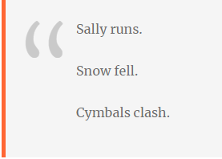
But put together a noun and a very, and you have meaning. Tiny two-word sentences like these are the most concise examples of grammar at work. From there, grammar describes all the ways we can add words so that each one makes sense and brings clarity.
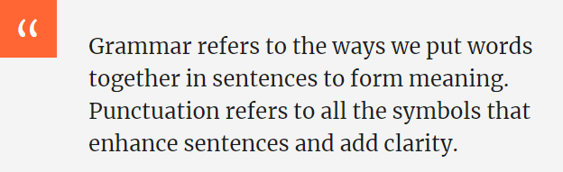

What is Punctuation?
Punctuation refers to all the little symbols we use to enhance sentences and add clarity. These symbols can indicate pauses between ideas, the relationships between words, and even the emotion sentences convey, amongst other things.

You’re probably familiar with the most common punctuation marks:

A full stop (.) separates sentences. The name itself – full stop – is a great way to describe the way it brings a sentence to a halt.
A comma (,) creates a smaller pause in the middle of sentences. It can divide content by clause, delineate list items from one another (that’s what all the commas in this sentence are for), and indicate sentence continuation before and after quotation marks.
A question mark (?) makes it clear that a sentence isn’t simply a statement, but a question.
An exclamation point (!) changes the tone of a sentence to convey emotions like excitement, enthusiasm, or urgency.

There are 10 more punctuation marks you can add to your sentences as they become more complicated but a strong grasp of these first four will cover most of your writing.
True or False: A verb is a word that expresses an action or a state of being. Click here to enter text.
Take the Quiz: Take the punctuation quiz. What’s your score? Click here to enter text.
Question: Can you name the 10 other punctuation marks mentioned in the article above? Click here to enter text.

Safeguarding - The Crisis in Ukraine
The Department for Education and the government have established Key Themes as specific topics that aim to enrich your learning by improving your wider skills and understanding above and beyond the course you are taking. Skills South Tyneside and your training provider want you to gain the most from your programme of learning and these activities will help to embed those Key Themes. The Key Themes are:
M-  Maths | E-  English | ILT- Information Learning Technology | EDI- Equality, Diversity Inclusion | S-  Safeguarding | P- Prevent | C-  Climate | HS- Health and Safety | BV-  British Values
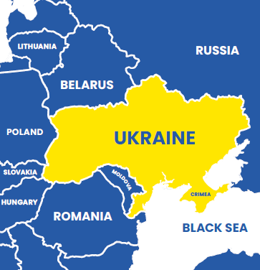
Why is Ukraine in the news?
Russia invaded Ukraine on 24th February 2022. The lead-up to the war began last year when Russia began positioning tens of thousands of soldiers along its border with Ukraine – then more inside the country of Belarus, a Russian ally.
Why did Russia invade?
Russia says it wants to know that Ukraine won’t join NATO (the North Atlantic Treaty Organisation). NATO is an international organisation that guarantees the freedom of its member countries. Russian president Vladimir Putin thinks that, if Ukraine joins, it will give the USA and its allies too much power right next to the Russian border. Russia has also demanded NATO removes all troops from Bulgaria and Romania. Thousand of Russian people who don’t agree with President Putin’s decision to go to war have been protesting in cities across the country.
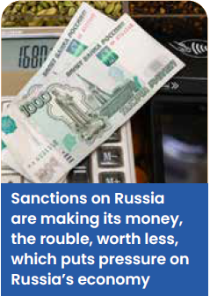
Are world leaders trying to resolve the crisis?
Yes. There have been talks between Russia and Ukraine to try to stop the conflict. The UK, EU, USA and other countries are making it tough for Putin by bringing in sanctions – penalties given to a country that is behaving badly. Sanctions make it difficult for a country to make money, so it can’t carry on as normal. NATO has said it won’t get involved directly with fighting.
Ukraine fights back:
Although Russia’s military is much bigger and has better equipment, Ukrainian troops are fiercely and bravely defending their country. They are also being helped by many civilians who have bought weapons and taken shooting lessons in recent months. Some Ukrainian businesses have even stopped producing goods so they can make weapons and army supplies instead.
Worrying About War?
The news from Ukraine is unsettling for everyone. Hopefully the information above has helped you understand things better but when you hear a worrying headline, or alarming stories are thrown about, it can be upsetting. Knowing more about what’s going on has hopefully removed any ‘fear of the unknown’ you’re experiencing but if you’re still anxious here are some practical tips:
- Get the facts – you might hear people talking about what might happen next in Ukraine or the rest of the world but often that’s opinion that isn’t based on fact. Double check the information on what’s happening with unbiased sites you can trust like the BBC, The Associated Press and Reuters.
- Take a break – when the news is particularly worrying sometimes taking a media break including from social media can really help. Use this time to do something that relaxes you and remember to turn off your notifications too.
- Do something positive – there are some basic things we can all do. Reach out and support a friend who’s upset or share something positive online. Doing things to help other people can help you to cope and feel more in control.
You can choose to do any or all the suggested activities below and your tutor will support you with any help you may need:
Question: how did this article make you feel? Click here to enter text.
Research Online: what is unbiased news? What are examples of biased media or ‘fake news’? Click here to enter text.
Careers – Plan Your Next Steps in Employment
The Department for Education and the government have established Key Themes as specific topics that aim to enrich your learning by improving your wider skills and understanding above and beyond the course you are taking. Skills South Tyneside and your training provider want you to gain the most from your programme of learning and these activities will help to embed those Key Themes. The Key Themes are:
M-  Maths | E-  English | ILT- Information Learning Technology | EDI- Equality, Diversity Inclusion | S-  Safeguarding | P- Prevent | C-  Climate | HS- Health and Safety | BV-  British Values

In what has been dubbed ‘The Great Resignation’ almost one in four UK workers are planning a job change in 2022. A survey of 6,000 workers by the recruitment firm Randstad UK found that 69% of people were feeling confident about moving to a new role in the next few months, with 24% planning a change within three to six months. The company has said that previously up to 11% of workers to move jobs every year with the conclusion that the pandemic has forced all of us to reassess our lives and make changes. If you are unsure of what direction you’d like to go in use Career Coach – Skills South Tyneside’s interactive career assessment tool and career explorer:

So what can you do if you’re feeling like a change in career to set you up for the best possible outcome?

Update Your CV
Update your CV and do so from the top. Carefully update your CV and crystallise all important details at the very beginning. What achievements did you attain in the previous year? It is also critical to highlight your soft skills such as communication skills and team work because often employers will give equal or more weight to soft skills like your ability to work well with a team or think critically.

Competencies
Don’t get into the habit of applying for random jobs. A key career tip in building certain skill sets is being deliberate about the roles, training and professional courses you apply for. Constantly update your skills to match the changes and remain relevant.

Network better
Ensure that all your social media platforms (specifically LinkedIn) clearly showcase your skills. This is not just about looking for a job, it also speaks into the kind of networks you would like to attract. After that, reach out to the people within your networks who might have connections to the organisations that you are targeting and ask for introductions.

Building activities
It takes lifelong learning to build a career. Devote some time while you are at home to something that directly influences your career positively. This could be taking an online course in your area. An important tip is also to remember to look at your career broadly — not just in terms of a particular employer or current role you are taking up. Local courses provided by South Tyneside Skills can be found here.

Useful links:
www.nationalcareers.service.gov.uk
www.notgoingtouni.co.uk
www.gov.uk/apply-apprenticeship
Climate - A Green Solution to Climate Change
The Department for Education and the government have established Key Themes as specific topics that aim to enrich your learning by improving your wider skills and understanding above and beyond the course you are taking. Skills South Tyneside and your training provider want you to gain the most from your programme of learning and these activities will help to embed those Key Themes. The Key Themes are:
M-  Maths | E-  English | ILT- Information Learning Technology | EDI- Equality, Diversity Inclusion | S-  Safeguarding | P- Prevent | C-  Climate | HS- Health and Safety | BV-  British Values
Allowing nature to thrive can help us combat climate change. One of the major drivers of climate change is the increasing level of carbon dioxide in our air, but by planting more trees, hedges and flowers, growing more fruit and veg and protecting our green spaces we can absorb a lot of this carbon – and put it to good use!
A Win-Win Solution!
While embracing green towns and cities will help to fight climate change it will also bring countless other benefits. When nature thrives, so do we. A healthier natural environment…
- Reduces air pollution | - Helps us stay active
- Benefits our mental health | - Reduces crime
- Supports our economy | - Regulates urban temperatures
- Tackles our biodiversity crisis | - Supports wildlife
- Improves our food security | - Reduces energy consumption
What Can You Do?
We need to start embracing nature in our urban spaces – in gardens, parks, on rooftops and everywhere in between. Soo…
🌱 Enhance your gardens and be creative with your outdoor space!

- Plant something (on windowsills and balconies, in front gardens and driveways, up walls and in gardens)
- Create wildlife-friendly features
- Grow your own fruit and vegetables (in any sized space)
- Garden with nature, not against it
- Give your lawnmower a rest
- Compost your food scraps and go peat-free
- Rethink “weeds”
🌱Get involved in community groups and volunteer to protect your local environment!
- Love South Tyneside by doing a Litter Pick or helping at a Community Garden
- Support your local parks and greenspaces. Get in touch with South Tyneside Council’s Community Engagement Officer, Emily Ross, for more information about volunteering opportunities near you
🌱Simply go out and enjoy nature!

- Go out to your local park, woodland or greenspace and take time to appreciate your local environment. Getting out into greenery can lower blood pressure, boost your immune system and help lift your mood!
What's on This Month
Earth Day - 22nd April
National Gardening Week - 30th April
Listen, Read, Watch
Listen to… BBC Why Does Nature Calm Anxiety?
Read… National Trust to Plant Blossom Trees in Cities
Watch… Tyne-Tees Murmurations in March 2021
You can choose to do any or all the suggested activities below and your tutor will support you with any help you may need:
Question: How do you contribute to your local environment being greener? Click here to enter text.

Health and Wellbeing – World Health Day – 7th April 2022
The Department for Education and the government have established Key Themes as specific topics that aim to enrich your learning by improving your wider skills and understanding above and beyond the course you are taking. Skills South Tyneside and your training provider want you to gain the most from your programme of learning and these activities will help to embed those Key Themes. The Key Themes are:
M-  Maths | E-  English | ILT- Information Learning Technology | EDI- Equality, Diversity Inclusion | S-  Safeguarding | P- Prevent | C-  Climate | HS- Health and Safety | BV-  British Values
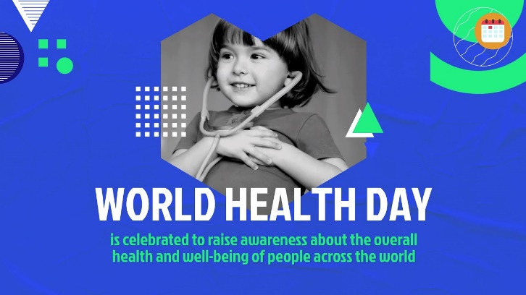
What is World Health Day?
The 7th April each year marks the celebration of World Health Day. From its inception at the First Health Assembly in 1948 and since taking effect in 1950, the celebration has aimed to create awareness of a specific health theme to highlight a priority area of concern for the World Health Organisation.

Over the past 50 years this has brought to light important health issues such as mental health, maternal and childcare health, and climate change. The celebration is marked by activities which extend beyond the day itself and serves as an opportunity to focus worldwide attention on the importance of global health.

Some Key Facts
- Of the 43.5 million health workers globally, it is estimated that 20.7 million are nurses
- Globally, 70% of the health and social workforce are women
- In the UK approximately 1.9 million people are employed in the healthcare workforce – this includes
- both public and private sector health workers such as doctors, nurses and paramedics
- The largest employer in the UK healthcare sector is the NHS which employs more than 1.5 million
- people – placing it in the top five largest workforces in the world. There are more than 350 different
- roles available in the NHS.

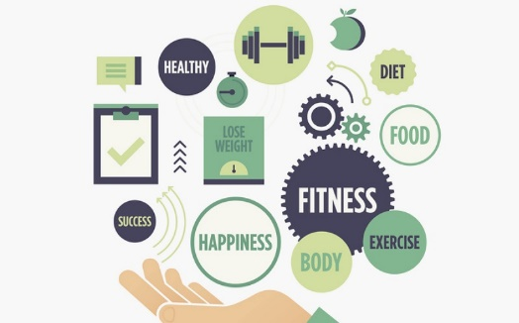
How to Improve Your Health and Wellbeing:
- Look for ways to move more – take short breaks and walk around your area or get off the bus one stop early, take the lift instead of the stairs or while sitting do some desk-ercise.
- Try to incorporate fruit and vegetables in every meal you have – the added nutrients will make you feel better physically, emotionally and mentally
- Drink more water – aim for 8 glasses a day!
- Look for moments in your day to practice being mindful – breath deeply, be present and think of something you’re grateful for.

To find out more visit: https://www.who.int/news-room/campaigns/world-health-day

You can choose to do any or all the suggested activities below and your tutor will support you with any help you may need:
Question: What do you think is the biggest healthcare crisis facing the world? Click here to enter text.
Research Online: In 2017 what amount did the UK spend per person on healthcare? Click here to enter text.

