Maths Activity – Financial Mathematics
The Department for Education and the government have established Key Themes as specific topics that aim to enrich your learning by improving your wider skills and understanding above and beyond the course you are taking. Skills South Tyneside and your training provider want you to gain the most from your programme of learning and these activities will help to embed those Key Themes. The Key Themes are:
M-  Maths | E-  English | ILT- Information Learning Technology | EDI- Equality, Diversity Inclusion | S-  Safeguarding | P- Prevent | C-  Climate | HS- Health and Safety | BV-  British Values
Financial maths is needed for all jobs, from calculating wages to working out profit, loss and VAT. Knowledge of financial maths is also required to be able to understand bank statements and savings.

Wages are paid by an employer to their staff in return for work. Wages are usually paid weekly or monthly. They are either calculated on a rate of pay per hour or has an annual salary. In Britain, people should be paid at least the minimum wage rate set by the government. The value of the minimum age varies depending on whether the person working is an apprentice, under the age of 18, or an adult.

If a person earns £5.52 per hour and works 10 hours per week, they would earn £55.20.
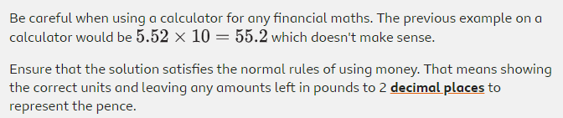

In some jobs, people may be paid for any extra hours they work or overtime. Complete the table:
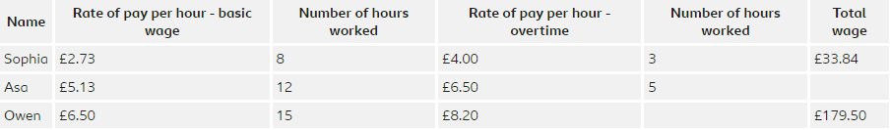

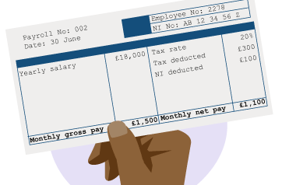
To work out Asa’s total wage for the week, multiply the hourly rates by the hours worked:
(£5.13 x 12) + (£6.50 x 5) = £94.06
To work out how much overtime Owen did, firstly, find Owen’s basic wage:
£6.50 x 15 = £97.50
Find the difference between the basic wage and total wage:
£179.50 - £97.50 = £82.00
Divide the overtime pay by the hourly rate:
£82 / £8.20 = 10 hours

Salary usually refers to the amount of money a person earns over a year. For example, if a shop assistant has a salary of £18,000 per year, their monthly pay would be £1,500 (£18,000 / 12 months). £1,500 is the gross pay.
- Gross pay is the full amount paid to an employee before any deductions are made.
- Deductions are income tax, national insurance and sometimes pension contributions.
- Net pay is what’s left after deductions have been made from gross pay. This is the amount an employee receives.
Question: Stephanie wants to work out her annual salary, she says “there are 4 weeks in a month so I will multiply my weekly wage of £420 by 4. There are 12 months in a year, so I will multiply the answer by 12: £420 x 4 x 12 = £20,160”. Is this correct? Click here to enter text.
Watch Online: watch the videos to understand how to check a payslip using addition and multiplication. If you earned £7.82 an hour and worked 37 hours per week what would your annual salary be? Click here to enter text.
Careers – Your Next Steps Live – The STEM Edition
The Department for Education and the government have established Key Themes as specific topics that aim to enrich your learning by improving your wider skills and understanding above and beyond the course you are taking. Skills South Tyneside and your training provider want you to gain the most from your programme of learning and these activities will help to embed those Key Themes. The Key Themes are:
M-  Maths | E-  English | ILT- Information Learning Technology | EDI- Equality, Diversity Inclusion | S-  Safeguarding | P- Prevent | C-  Climate | HS- Health and Safety | BV-  British Values
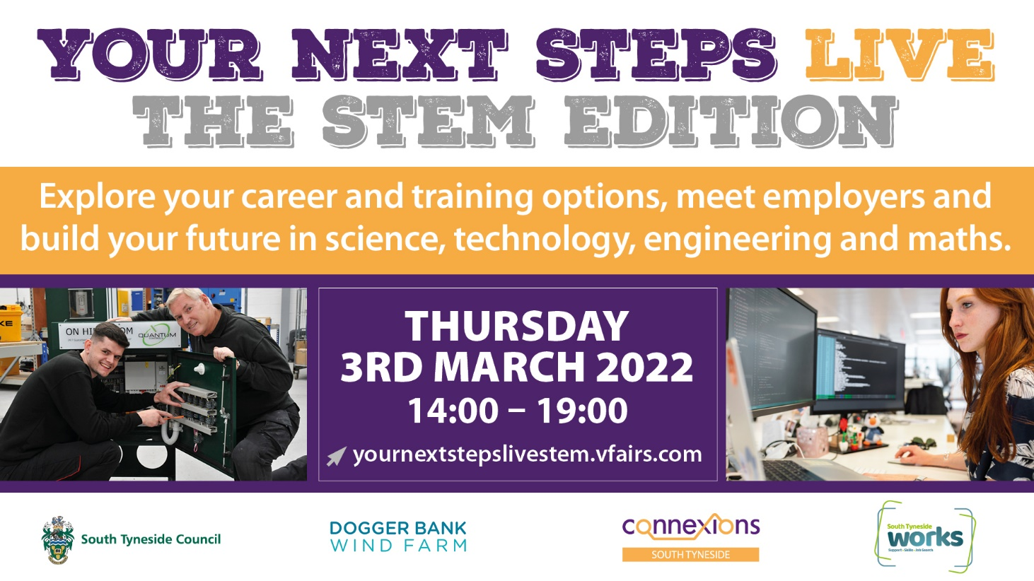
Your Next Steps Live – The STEM Edition is our virtual careers fair which will take place on Thursday 3rd March between 2-7pm.

Making choices and decisions about your next steps can be overwhelming, but knowing what opportunities are available and how you can access them can help inform your decision making and put your mind at ease.

A variety of industries rely on individuals with STEM-based qualifications and skills who can make a contribution to the big challenges facing society today. Careers in science, technology, engineering and maths are all around us and critical for everyday life, from COVID-19 Research Assistants to the Software Developers who built this virtual career fair – there’s 1000’s of jobs in STEM which you may not know about…yet.

Did you know, South Tyneside is an industry leader in sectors such as low-carbon heat, mine energy and renewable technology with Dogger Bank, the world’s largest wind farm being constructed off our coastline and have a base at Port of Tyne – when complete the wind farm will power 5 million homes, or about 5 per cent of total UK demand.

Also on your doorstep, you also have International Advanced Manufacturing Park (IAMP) which over the next 10 years will bring 7000 new jobs to the region with opportunities in engineering and manufacturing – for example automotive, energy technology, aerospace, other transport sectors. The region is home to a cluster of almost 1,500 advanced manufacturing businesses employing 62,500 workers with automotive manufacturing employing over 30,000 people in the region – more than any other UK region.

Find out more about education, employment and training opportunities in STEM by attending Your Next Steps Live – The STEM Edition – register now at: https://yournextstepslivestem.vfairs.com/

Equality and Diversity - International Women’s Day 2022
The Department for Education and the government have established Key Themes as specific topics that aim to enrich your learning by improving your wider skills and understanding above and beyond the course you are taking. Skills South Tyneside and your training provider want you to gain the most from your programme of learning and these activities will help to embed those Key Themes. The Key Themes are:
M-  Maths | E-  English | ILT- Information Learning Technology | EDI- Equality, Diversity Inclusion | S-  Safeguarding | P- Prevent | C-  Climate | HS- Health and Safety | BV-  British Values
International Women's Day (8th March) is a global day celebrating the social, economic, cultural and political achievements of women. The day also marks a call to action for accelerating gender parity.
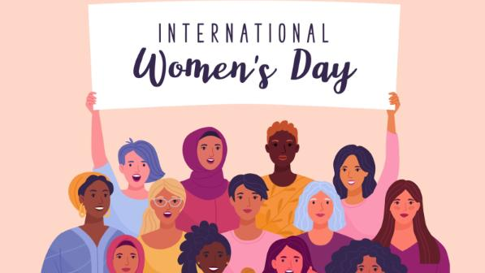
The theme of International Women’s Day 2022 is #breakthebias. Imagine a gender equal world. A world free of bias, stereotypes, and discrimination. A world that is diverse, equitable, and inclusive. A world there difference is valued and celebrated. Together we can forge women’s equality. Collectively we can #breakthebias.

What is Gender Bias?
Gender bias is defined as prejudiced actions or thoughts based on the gender-based perception that women are not equal to men in rights and dignity.

Show Your Support
Strike the IWD 2022 Break The Bias pose by crossing your arms to show solidarity and share your #breakthebias image, video, resources, presentation or articles on social media using #IWD2022 #BreakTheBias to encourage further people to commit to helping forge an inclusive world.


Celebrations Go Virtual
Due to COVID-19 the usual celebrations and events have moved online with a huge range of options available so you can take part with events all over the world – making this a truly international day.
For more events check out https://www.internationalwomensday.com/EventList
True or False: The Equality Act 2010 protects women from discrimination based on their gender. Click here to enter text.
Research Online: What year were women given the right to vote in the UK? What women-led movement helped this change? Click here to enter text.
Safeguarding - Stop Child Exploitation Awareness Day – 18th March 2022
The Department for Education and the government have established Key Themes as specific topics that aim to enrich your learning by improving your wider skills and understanding above and beyond the course you are taking. Skills South Tyneside and your training provider want you to gain the most from your programme of learning and these activities will help to embed those Key Themes. The Key Themes are:
M-  Maths | E-  English | ILT- Information Learning Technology | EDI- Equality, Diversity Inclusion | S-  Safeguarding | P- Prevent | C-  Climate | HS- Health and Safety | BV-  British Values

Child Sexual Exploitation (CSE) is a form of sexual abuse that involves the manipulation and/or coercion of young people under the age of 18 into sexual activity. The National Child Exploitation Day aims to highlight the issues surrounding Child Exploitation; encouraging everyone to think, spot and speak out against abuse and adopt a zero tolerance to adults developing inappropriate relationships with children or children exploiting and abusing their peers.

NWG (formerly the National Working Group for Sexually Exploited Children and Young People) is a charitable organisation formed as a UK network of over 14,500 practitioners who disseminate information down through their services, to professionals working on the issue of child exploitation (CE) and trafficking within the UK. NWG are committed to the fight against CSE and CE and supporting victims and their families who are subjected to child exploitation. But they cannot succeed without the support of people like you.

Child Abuse in the UK – The Facts
- Over 90% of sexually abused children are abused by someone they know
- Over 50,000 children in the UK have been identified as needing protection from abuse
- It’s not just adults that abuse children; 65.9% of the contact sexual abuse reported by children and young people was perpetrated by other children and young people
- Neglect effects up to 1 in 10 children in the UK
- It is a myth that those abused as children will become abusers as adults

Together, we can work to inform, educate and prevent child abuse within the UK.

There are various ways you can show your support. Write a personal pledge on your hands to show support for the Helping Hands campaign. Post your photo on social media with the hashtag #HelpingHands and #CEADay22 to help NWG raise awareness of CSE and wider exploitation. You can help to give victims a voice.
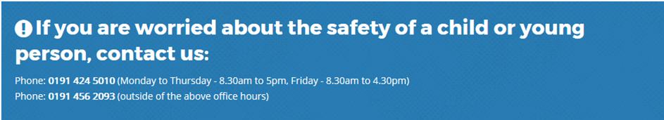
You can choose to do any or all the suggested activities below and your tutor will support you with any help you may need:
Question: What different forms of abuse could young people suffer? Click here to enter text.
Research Online: What role can technology play in child sexual exploitation? Click here to enter text.
Question: The Crime Survey for England and Wales estimated that one in five adults aged 18-74 years experienced at least one form of child abuse before the age of 16 years (8.5 million people). What is 1 in 5 as a percentage? Click here to enter text.
Climate Change in South Tyneside
The Department for Education and the government have established Key Themes as specific topics that aim to enrich your learning by improving your wider skills and understanding above and beyond the course you are taking. Skills South Tyneside and your training provider want you to gain the most from your programme of learning and these activities will help to embed those Key Themes. The Key Themes are:
M-  Maths | E-  English | ILT- Information Learning Technology | EDI- Equality, Diversity Inclusion | S-  Safeguarding | P- Prevent | C-  Climate | HS- Health and Safety | BV-  British Values
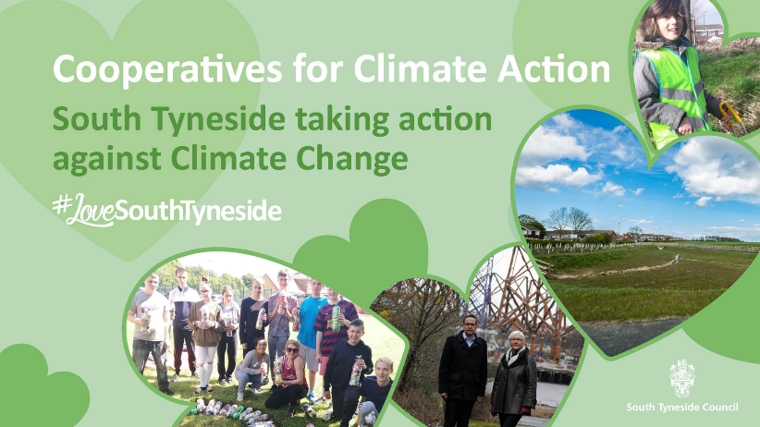
Climate change will affect South Tyneside in ways you may already understand – like flooding, droughts and heatwaves – but also in ways you may not have anticipated such as food insecurity, mass migration, local extinctions, further pandemics and resulting global financial crises. But the good news is, while combatting climate change will be a significant challenge, it’s not too late to change course.

The Covid-19 pandemic has been tough. It has presented us with some extremely testing and difficult times. But it has also brought many of us closer to nature, benefitting from fewer cars on the road, more birdsong and a greater awareness of our local wildlife. In pursuit of different places to exercise, many of us will have discovered new and exciting areas nearby, leading to an increase in community spirit and a new-found appreciation for our local green spaces.

In some circumstances, it has given us opportunities to reflect on how we live our lives and how we might be able to change for the better in the future. Instead of returning ‘back to normal’, we now have the opportunity to build back better.

South Tyneside Council is leading the way in creating a Sustainable South Tyneside. In 2019, we declared a ‘Climate Emergency’. Since then, we have adopted our 5-year Climate Change Strategy and Action Plan, which includes a commitment to become carbon neutral by 2030 www.southtyneside.gov.uk/climatechange to see why reducing carbon emissions are so important.

What Can You Do? 1st-7th March is Food Waste Action Week

Food waste is a big environmental problem.
- Food is responsible for 30% of the world’s greenhouse gas emissions.
- Food production is the number 1 cause of biodiversity loss. And yet;
- 1/3 of food produced is wasted.
- 70% of the food that is wasted in the UK is wasted by people in their own homes.
Check out the WRAP website where you can find recipes and ideas on meal planning to help you stop wasting food in your home. You can also check out @lfhw_uk on Instagram.
You can choose to do any or all the suggested activities below and your tutor will support you with any help you may need:
Research Online: What can we do personally to reduce our carbon emissions and reduce our carbon footprint? Click here to enter text.
Question: In what ways has COVID-19 changed your lifestyle and does this reduce your carbon footprint? Click here to enter text.

