Maths Quick Activity – how to find the mean, median, mode and range.
The Department for Education and the government have established Key Themes as specific topics that aim to enrich your learning by improving your wider skills and understanding above and beyond the course you are taking. Skills South Tyneside and your training provider want you to gain the most from your programme of learning and these activities will help to embed those Key Themes. The Key Themes are:
M-  Maths | E-  English | ILT- Information Learning Technology | EDI- Equality, Diversity Inclusion | S-  Safeguarding | P- Prevent | C-  Climate | HS- Health and Safety | BV-  British Values
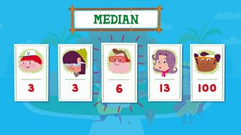
The median is the middle value.
- To find the median, order the numbers and see which one is in the middle of the list.
- Eg 3, 3, 6, 13, 100 = 6
- The median is 6.
If there are two middle values the median is halfway between them. This might not be a whole number.
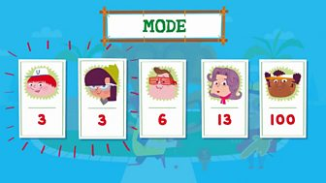
The mode is the number that appears the most.
- To find the mode, order the numbers lowest to highest and see which number appears the most often.
- Eg 3, 3, 6, 13, 100 = 3
- The mode is 3.

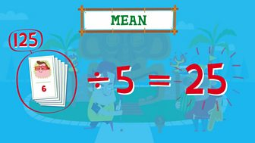
The mean is the total of the numbers divided by how many numbers there are.
- To find the mean, add all the numbers together then divide by the number of numbers.
- Eg 6 + 3 + 100 + 3 + 13 = 125 ÷ 5 = 25
- The mean is 25.
The mean is not always a whole number.
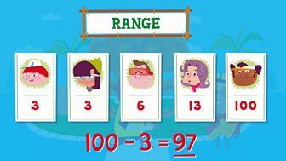
The range is the difference between the biggest and the smallest number.
- To find the range, subtract the lowest number from the biggest number.
- Eg 100 - 3 = 97
- The range is 97.
A measure of average is a value that is typical for a set of figures. Finding the average helps you to draw conclusions from data. The main types are mean, median, mode and range. Here’s a quiz for you to practice what you’ve learned.
You can choose to do any or all the suggested activities below and your tutor will support you with any help you may need:
Question: what did you learn from this article? Click here to enter text.
Question: list each of your family members ages (included extended family if that helps) and find the mean, median, mode and range for them. Click here to enter text.
Question: can you think of any circumstances where you would need to find the median value? Click here to enter text.

Health and Wellbeing – Dry January
The Department for Education and the government have established Key Themes as specific topics that aim to enrich your learning by improving your wider skills and understanding above and beyond the course you are taking. Skills South Tyneside and your training provider want you to gain the most from your programme of learning and these activities will help to embed those Key Themes. The Key Themes are:
M-  Maths | E-  English | ILT- Information Learning Technology | EDI- Equality, Diversity Inclusion | S-  Safeguarding | P- Prevent | C-  Climate | HS- Health and Safety | BV-  British Values
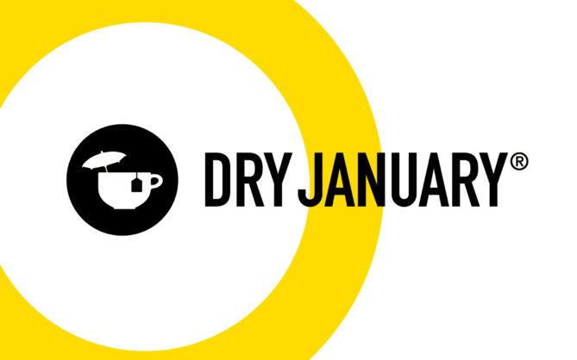
This week is the start of Dry January. Dry January is the UKs one-month alcohol free challenge. It isn’t about giving anything up. It’s about getting something back. Get your fun back. Get your energy back. Get your calm back. Get your ‘YOU’ back.

After the excesses of the festive period, January provides an ideal opportunity to start the New Year with your own health and wellbeing at the front of your mind.

In previous years:
- 86% of participants saved money
- 70% slept better, and
- 66% had more energy

Here are some top tips to support you cutting down and getting prepared for the month ahead:

- Throw it away! If you’re planning on doing Dry January, the best thing to do is remove all the booze from your home. Throw it away or, if you can’t stand the idea of a half-bottle of spiced rum going to waste, put it somewhere hard to get to like your attic or somewhere else with lots of spiders.
- Make a plan for situations where alcohol is on offer. This Dry January it’s less likely that you’ll be regularly visiting pubs, bars or restaurants for big social gatherings due to ongoing covid restrictions that might be in place. But in case you do end up in one of those situations, you need to be prepared. Deciding beforehand what you’re going to do will really help you when the time comes. Whether it’s sticking to alcohol-free alternatives (that still look the real deal), having soft drinks or practicing saying no, make sure you have a plan.
- Treat yourself. Not drinking for a month will save you money. And you should use that money to treat yourself. If you ever feel a craving coming on, remind yourself that with every drink you don’t buy, you’re one step closer to buying yourself a holiday, some new shoes or a fancy dinner. That’s great motivation!
- Assemble your support group. You can try Dry January along if you want to but it’s a lot easier with the support of your friends and family. You could even suggest that two (or more!) of you do it together so you can keep each other motivated. Even if no one else wants to join you on your dry journey, it’s important to have a support network in place – people who won’t ply you with drinks, and to encourage you if things are tricky. Your sober buddies don’t have to be physically there – you can even find support through the Dry January Facebook Community.
- Fill the gap with fun stuff. Now its winter, days are short. Even shorter if you’re hungover and trying to sleep it off. Now that you’re sober, you’ll have much more time to spend on things you enjoy! Read a book, learn something new, take a class, go for a walk or a run – just make sure you’re having fun.

The most important thing to remember for Dry January is to enjoy it. It’s not meant to be a month of deprivation – it’s your chance for a break, to see what life without alcohol is like.

For more information see Alcohol Change UK. You can also download the app Try Dry to support you.
You can choose to do any or all the suggested activities below and your tutor will support you with any help you may need:
Take the Quiz: what type of drinker are you? Click here to enter text.

Equality and Diversity - World Religion Day – 16th January 2022
The Department for Education and the government have established Key Themes as specific topics that aim to enrich your learning by improving your wider skills and understanding above and beyond the course you are taking. Skills South Tyneside and your training provider want you to gain the most from your programme of learning and these activities will help to embed those Key Themes. The Key Themes are:
M-  Maths | E-  English | ILT- Information Learning Technology | EDI- Equality, Diversity Inclusion | S-  Safeguarding | P- Prevent | C-  Climate | HS- Health and Safety | BV-  British Values
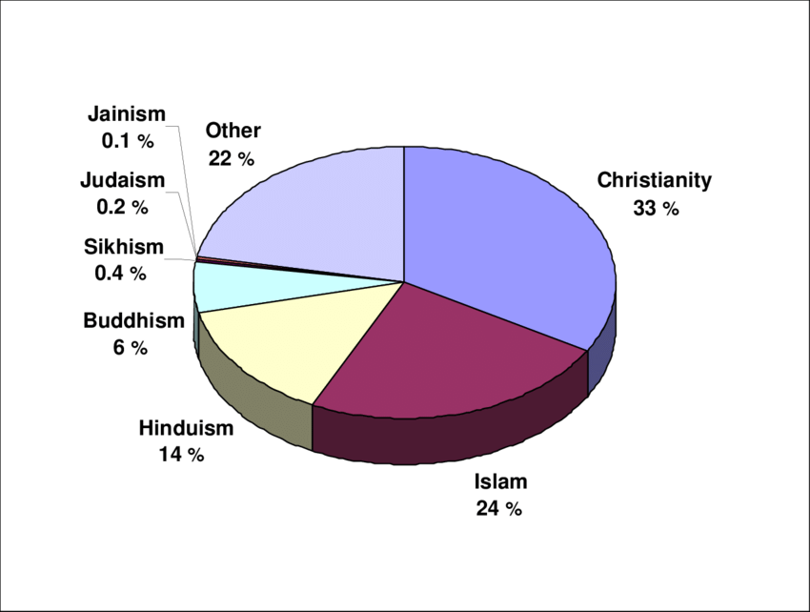
World Religion Day is celebrated every January on the third Sunday of the month. The aim of World Religion Day is to promote understanding and peace between all religions, encouraging people to learn about other faiths and their followers.

It was initially started by followers of the Bahá’í faith. This is a faith that was founded in 1863 in Iraq. Bahá’ís believe that all religions have common features and that all religions should be respected. They believe that there is one God who is known by different names in all religions. In their faith, this God is the reason for the development of all religions over the years. Followers of the Bahá’í faith believe that all humans are born equal, and that we all have the same rights regardless of the religion or creed we follow.

The day calls for members of all religions in the world to recognize that religion all has a common spiritual goal, and it aims to promote the unity of religious peoples and overcome historical differences. For centuries, different religions and faiths have fought both ideologically and physically for the dominance of their religion. World Religion Day seeks to overcome this and achieve a peaceful understanding between faiths.

How is World Religion Day Celebrated?
World Religion Day is celebrated in a variety of ways. Many people will attend special services which centre around respecting other religions and reflecting on the universal message of the six main religions: treating each other with respect and understanding to create a better world for everyone. Special services are held around the world to celebrate similarities, create understanding and to show how we can work together to create a better world.

What Are the Six Major Religions?
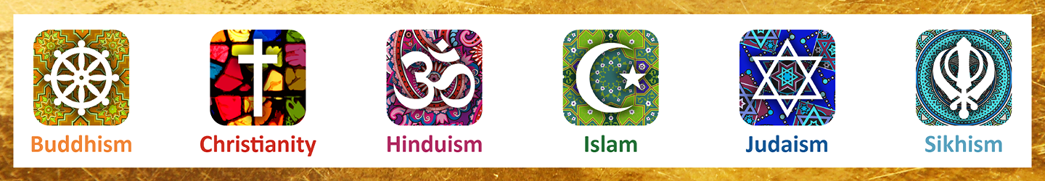
The six major religions of the world are Christianity, Buddhism, Islam, Hinduism, Judaism and Sikhism. These are the most widely practised religions in the world. Nearly seventy-five per cent of the world practices one of these six religions.
You can choose to do any or all the suggested activities below and your tutor will support you with any help you may need:
Question: what did you learn from this article? Click here to enter text.
Question: if there are 7.5 billion people in the world and 75% of them practice the 6 main religions, how many people is this? Click here to enter text.
Why Give Blood?
The Department for Education and the government have established Key Themes as specific topics that aim to enrich your learning by improving your wider skills and understanding above and beyond the course you are taking. Skills South Tyneside and your training provider want you to gain the most from your programme of learning and these activities will help to embed those Key Themes. The Key Themes are:
M-  Maths | E-  English | ILT- Information Learning Technology | EDI- Equality, Diversity Inclusion | S-  Safeguarding | P- Prevent | C-  Climate | HS- Health and Safety | BV-  British Values
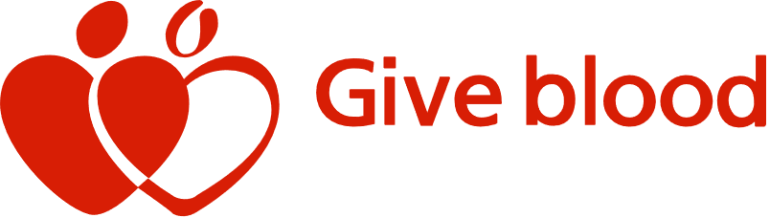
Giving blood saves lives. The blood you give is a lifeline in an emergency and for people who need long-term treatments. The NHS needs new blood donors from all backgrounds to ensure there is the right blood available for patients who need it. The NHS currently needs:
- Nearly 400 new donors a day to meet demand
- Around 145,000 new donors a year to replace those who can longer donate
- 40,000 more black donors to meet growing demand for better matched blood
- 30,000 new donors with priority bloody types such as O negative every year
- More young people to start giving blood so there is enough blood supply in the future
Blood types
There are eight main blood types but some are rarer than others. The list below shows the percentage of donors with each blood type:

O positive | 35% | O negative | 13%
A positive | 30% | A negative | 8%
B positive | 8% | B negative | 2%
AB positive | 2% | AB negative | 1%

You can receive blood from a donor with the same blood type as you. You can also receive blood from a donor with a compatible blood type. Similarly, a person with a different blood type to you may be able to safely receive your blood. O negative blood is known as the universal blood type because it is safe for everyone to receive O negative red cells. You will find out your blood type after your first donation.

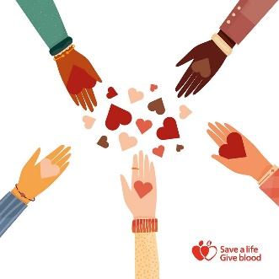
How blood is used
Blood or the components of blood are used to treat patients with medical conditions such as anaemia, cancer blood disorders, and those having surgery. How blood was used in 2014, according to hospital usage:
- 67% was used to treat medical conditions including anaemia, cancer and blood disorders, such as sickle cell
- 27% was used in surgery, including cardiac surgery and emergency surgery
- 6% was used to treat blood loss after childbirth

Become a blood donor
To get started, you’ll need to register your details on the NHS database. You will be asked to answer some basic questions to check you are most likely to be able to donate, register and validate your email address, complete your personal details to set up your account. Your blood donation is an amazing gift to people who need it in an emergency or for on-going medical treatment.

You can choose to do any or all the suggested activities below and your tutor will support you with any help you may need:
Question: what did you learn from this article? Click here to enter text.
Question: have you ever given blood, or have you received a blood transfusion? How did you find the experience? Click here to enter text.
Question: if 400 new blood donors are needed a day, how many is this in a year? Click here to enter text.

Smoking and the Environment
The Department for Education and the government have established Key Themes as specific topics that aim to enrich your learning by improving your wider skills and understanding above and beyond the course you are taking. Skills South Tyneside and your training provider want you to gain the most from your programme of learning and these activities will help to embed those Key Themes. The Key Themes are:
M-  Maths | E-  English | ILT- Information Learning Technology | EDI- Equality, Diversity Inclusion | S-  Safeguarding | P- Prevent | C-  Climate | HS- Health and Safety | BV-  British Values
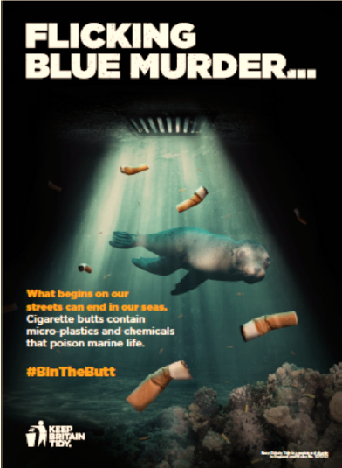
#BinTheButt is a campaign developed by Keep Britain Tidy for local authorities, to help stamp out the smoking related litter issue.

Dropped cigarette butts are the most common form of littering, found on 79% of the 7,200 sites surveyed as part of our recent Local Environment Quality Survey of England 2017/18.

Recent research revealed:
- 52% of smokers who smoke everyday thought putting a cigarette down the drain was acceptable.
- 39% of smokers, equivalent to 3.6million in the UK, admitted to throwing a cigarette butt down a drain within the past month.
- 11% of smokers do not consider cigarette butts to be litter.
As well as plastic, cigarette filters are comprised of thousands of chemical ingredients, including arsenic, lead and nicotine, all of which can leak into marine environments. According to studies, just one cigarette butt per litre of water is highly toxic to fish.
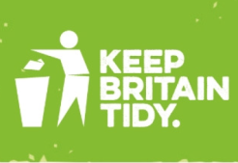
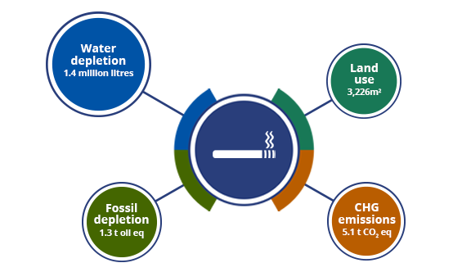
The #BinTheButt campaign aims to raise awareness amongst smokers and highlight the link between the cigarette butt they drop on the street or down the drain and the impact it has on the marine environment.

The image to the right shows the environmental impacts of a lifetime of smoking i.e. a person smoking a pack of 20 cigarettes a day for 50 years.

The World Health Organisation states that just in 1995 alone it was estimated that global tobacco manufacturing produced over 2 million tonnes of solid waste, 3 million tonnes of non-recyclable nicotine-containing waste and 2 million tonnes of chemical waste.

If you want to stop smoking, you can make small changes to your lifestyle that may help you resist the temptation to light up. The NHS Live Well campaign gives 10 self-help tips to stop smoking as well as links to advice and further support if you need it.
You can choose to do any or all the suggested activities below and your tutor will support you with any help you may need:
Question: is dropping a cigarette butt in the street illegal? Click here to enter text.
Research Online: in the UK, 15.9% of men smoked compared with what percent of women? Click here to enter text.

