Why are English and maths so important?
The Department for Education and the government have established Key Themes as specific topics that aim to enrich your learning by improving your wider skills and understanding above and beyond the course you are taking. Skills South Tyneside and your training provider want you to gain the most from your programme of learning and these activities will help to embed those Key Themes. The Key Themes are:
M-  Maths | E-  English | ILT- Information Learning Technology | EDI- Equality, Diversity Inclusion | S-  Safeguarding | P- Prevent | C-  Climate | HS- Health and Safety | BV-  British Values
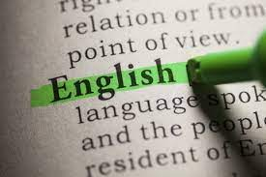
English is important because anything you do that involves other people is done through the medium of language. If you have a poor grasp of your own language this will affect the standard of everything you do. You can have fantastic ideas, but language is what brings them to life. If you cannot put your concepts into words, no one will ever know about them.

Maths is also used in everyday life. It is important because it allows people to take complex processes and make them more manageable, by applying structure, patterns, and rules. This is a skill that transfers to many situations in both professional and personal contexts. Studying maths is a way to develop the appropriate mental tools for dealing with the complex realities of life.

1. Further study opportunities
Many further education and university courses require a good level of English and maths - regardless of the subject. Typically, Level 2 is the minimum required. Level 2 is equivalent to GCSE grade 4 or higher (old grading system A*-C).
2. Employment opportunities
Employers want applied and practical skills including approximation, mental arithmetic, capability with visual data, a solid grasp of units of measurement, the ability to check their own calculations and simple problem-solving. A major survey of skill levels among adults in work found that, for employers, English skills are of greatest concern. Communication skills (listening and speaking) such as good writing, spelling, grammar and vocabulary could be improved. Lack of maths skills is another barrier to employment – people with low maths skills are twice as likely to be unemployed. BBC Bitesize has lots of activities based on how you would use maths and English in different work sectors.
3. Income
Employees who achieve good GCSE grades (Level 2 or equivalent) are likely to be earning at least £2,000 per year more than those who do not. Barclays Lifeskills has a range of resources that can help to give you the knowledge and confidence you need for work with tools, tips and learning resources.
4. Mental health
There is evidence to suggest that people with higher skills in English and maths have a longer life expectancy. Very recent studies are suggesting an emerging link that people with low levels of English and maths skills are more likely to suffer from mental health issues, specifically social, emotional and behavioural difficulties which often lead to playing truant from school. Crime may become an issue too – 65% of adult prisoners have low maths skills.
5. Life
With English and maths skills, you can access higher education, gain rewarding employment, earn more and potentially live a longer life. The good news is that it’s never too late to learn!

There are lots of maths and English courses available on the Skills South Tyneside website. There’s also the National Careers Service course finder or you call the helpline for free on 0800 100 900.
You can choose to do any or all the suggested activities below and your tutor will support you with any help you may need:
Question: what did you learn from this article? Click here to enter text.
Research Online: what are essential skills? Click here to enter text.

Alcohol Addiction and Abuse
The Department for Education and the government have established Key Themes as specific topics that aim to enrich your learning by improving your wider skills and understanding above and beyond the course you are taking. Skills South Tyneside and your training provider want you to gain the most from your programme of learning and these activities will help to embed those Key Themes. The Key Themes are:
M-  Maths | E-  English | ILT- Information Learning Technology | EDI- Equality, Diversity Inclusion | S-  Safeguarding | P- Prevent | C-  Climate | HS- Health and Safety | BV-  British Values
Alcohol abuse is drinking more than the recommended limits of alcohol consumption. The recommended daily limits for alcohol consumption are:
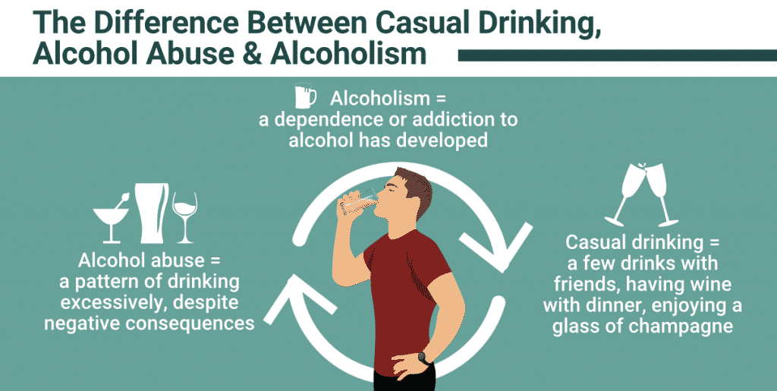
- No more than three to four units a day for men
- No more than two to three units a day for women
There are three main types of alcohol misuse:
- Hazardous drinking: drinking over the recommended limits
- Harmful drinking: drinking over the recommended limits and experiencing alcohol-related health problems
- Dependent drinking: feeling unable to function without alcohol
Risks of alcohol misuse include:
- Alcohol poisoning, which may include vomiting, seizures (fits) and unconsciousness
- Violent behaviour that might lead to being arrested by the police
- Unprotected sex that could potentially lead to unplanned pregnancy or a sexual transmitted infection
- Loss of possessions, such as a wallet, keys or phone, leading to feelings of anxiety
- Health problems such as strokes, liver disease, bowel cancer
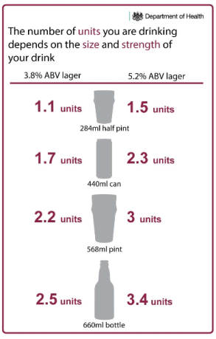
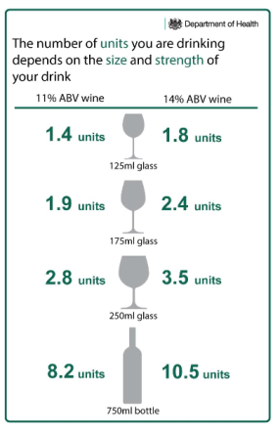
As well as health problems, long-term alcohol misuse can lead to social problems such as unemployment, divorce, domestic abuse, suicide and homelessness.

To see how many units you drink in a typical week, you can use the Drink Aware Units & Calorie Calculator.

Whilst out celebrating over Christmas and New Year please consider the following advice from Northumbria Police:
- Never accept drinks from a stranger
- Don't share or exchange drinks
- Never leave your drink unattended
- Don't just assume a friend is drunk - get them home safely.
For further information or to get help you can contact Alcoholics Anonymous on 0845 769 755 or the NHS.
You can choose to do any or all the suggested activities below and your tutor will support you with any help you may need:
Question: why should you never leave your drink unattended, or accept drinks from a stranger? Click here to enter text.
Research Online: what impact does drinking alcohol have on a person’s mental health? Click here to enter text.
Question: men and women are advised not to drink more than 14 units of alcohol a week. How many 250ml glasses of wine is this equivalent to? Click here to enter text.

Notice Check Share – Prevent Agenda
The Department for Education and the government have established Key Themes as specific topics that aim to enrich your learning by improving your wider skills and understanding above and beyond the course you are taking. Skills South Tyneside and your training provider want you to gain the most from your programme of learning and these activities will help to embed those Key Themes. The Key Themes are:
M-  Maths | E-  English | ILT- Information Learning Technology | EDI- Equality, Diversity Inclusion | S-  Safeguarding | P- Prevent | C-  Climate | HS- Health and Safety | BV-  British Values
Prevent is part of the UKs counter terrorism strategy, preventing people from becoming involved with or supporting terrorism. Radicalisation is defined as the process where someone had their vulnerabilities or susceptibilities exploited towards crime of terrorism – most often by a third party who have their own agenda.
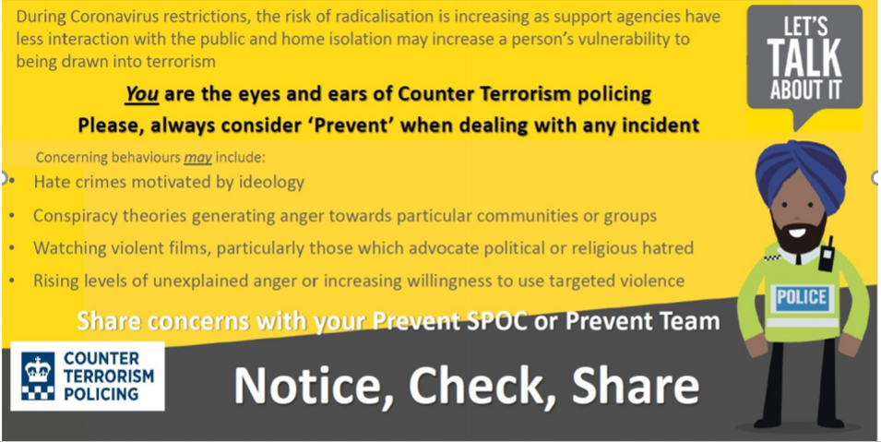

The Police are urging all of us to be vigilant against the threat of online radicalisation during the COVID-19 pandemic and remembering ‘Notice Check Share’ may help you if you know of someone who may be at risk.
- Notice – if you notice something of concern
- Check – check your concern and ask the opinion of your tutor, manager or someone you trust to see if they agree
- Share – share the concern if you/your trusted person feel that it is warranted.

If you are worried about a friend, relative or even yourself, please go to the Prevent “Let’s Talk About It” website or if you have immediate concerns please contact 101 where you can access discreet and tailored support from a trained professional.

For local Prevent contacts you can speak with South Tyneside Council Community Safety Team on 0191 424 7935 or Northumbria Police Prevent Team on 101 ext. 63855.
You can choose to do any or all the suggested activities below and your tutor will support you with any help you may need:
Question: what did you learn from this article? Click here to enter text.
Research Online: why are young people drawn into ISIS or Far Right Extremism ideologies? Click here to enter text.

Human Rights Day 2021 – 10th December
The Department for Education and the government have established Key Themes as specific topics that aim to enrich your learning by improving your wider skills and understanding above and beyond the course you are taking. Skills South Tyneside and your training provider want you to gain the most from your programme of learning and these activities will help to embed those Key Themes. The Key Themes are:
M-  Maths | E-  English | ILT- Information Learning Technology | EDI- Equality, Diversity Inclusion | S-  Safeguarding | P- Prevent | C-  Climate | HS- Health and Safety | BV-  British Values
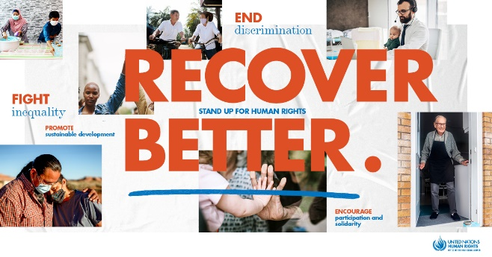
Human Rights Day is observed every year on 10 December — the day the United Nations General Assembly adopted, in 1948, the Universal Declaration of Human Rights (UDHR): a milestone document proclaiming the inalienable rights which everyone is inherently entitled to as a human being regardless of race, colour, religion, sex, language, political or other opinion, national or social origin, property, birth or other status. Available in more than 500 languages, it is the most translated document in the world.

2021 Theme: EQUALITY – Reducing inequalities, advancing human rights
The principles of equality and non-discrimination are at the heart of human rights. This includes addressing and finding solutions for deep-rooted forms of discrimination that have affected the most vulnerable people in societies, including women and girls, indigenous peoples, people of African descent, LGBTI people, migrants and people with disabilities amongst others. Equality, inclusion and non-discrimination, in other words – a human rights-based approach to development and resume our path towards realising a fairer future for everyone.
Human Rights must be at the centre of the post COVID-19 world
The COVID-19 crisis has been fuelled by deepening poverty, rising inequalities, structural and entrenched discrimination and other gaps in human rights protection. Only measures to close these gaps and advance human rights can ensure we fully recover and build back a world that is better, more resilient, just, and sustainable.
End discrimination of any kind: Structural discrimination and racism have fuelled the COVID-19 crisis. Equality and non-discrimination are core requirements for a post-COVID world.
Address inequalities: To recover from the crisis, we must also address the inequality pandemic. For that, we need to promote and protect economic, social, and cultural rights. We need a new social contract for a new era.

Encourage participation and solidarity: We are all in this together. From individuals to governments, from civil society and grass-roots communities to the private sector, everyone has a role in building a post-COVID world that is better for present and future generations. We need to ensure the voices of the most affected and vulnerable inform the recovery efforts.
Promote sustainable development: We need sustainable development for people and planet. Human rights, the 2030 Agenda and the Paris Agreement are the cornerstone of a recovery that leaves no one behind.
Question: what did you learn from this article? Click here to enter text.
Question: how long has the Universal Declaration of Human Rights (UDHR) been in place? Click here to enter text.
Research Online: what is structural discrimination and racism and how has this fuelled the COVID-19 crisis? What can we all do personally to combat structural racism? Click here to enter text.

