Remembrance Sunday – November 14th
The Department for Education and the government have established Key Themes as specific topics that aim to enrich your learning by improving your wider skills and understanding above and beyond the course you are taking. Skills South Tyneside and your training provider want you to gain the most from your programme of learning and these activities will help to embed those Key Themes. The Key Themes are:
M-  Maths | E-  English | ILT- Information Learning Technology | EDI- Equality, Diversity Inclusion | S-  Safeguarding | P- Prevent | C-  Climate | HS- Health and Safety | BV-  British Values

Remembrance Sunday, which falls on 14 November in 2021, is a national opportunity to remember the service and sacrifice of those that have defended our freedoms and protected our way of life. Rremembrance Sunday is observed as a commemoration of the contribution of British and Commonwealth military and civilian servicemen and women in the two World Wars and later conflicts. Observances include wearing of poppies, wreaths of remembrance poppies being laid on memorials and a two-minute silence at 11am.
Every year, the Royal British Legion supports Remembrance events across the UK. They encourage local and regional communities to produce Remembrance commemorations of their own.
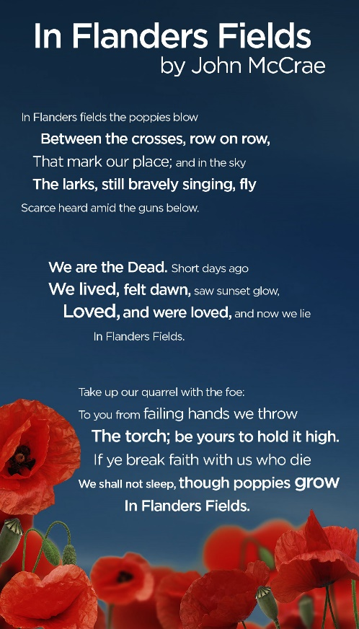
The poppy is a symbol of remembrance and hope, including hope for a positive future and peaceful world. They are a show of support for the Armed Forces community, those currently serving, ex-serving personnel and their families; and a symbol of Remembrance for all those who have fallen in conflict.

John McCrae wrote the poem In Flanders Fields which inspired the use of the poppy as a symbol of Remembrance. In the spring of 1915, shortly after losing a friend in Ypres, a Canadian doctor, Lieutenant Colonel John McCrae wrote his now famous poem after seeing poppies growing in battle-scarred fields.

Did you know?
- There’s no ‘correct’ way to wear a poppy – it’s all a personal choice reflecting individual and personal memories or emotions.
- Poppies are sold in every community across the UK and the sales of poppies directly supports the Armed Forces community.
- Poppies weren’t always sold with leaves – like the natural flower the original version of the poppy didn’t include a leaf.
- All parts of the poppies can be recycled – you can recycle yours at any Sainsbury’s supermarket.
You can choose to do any or all the suggested activities below and your tutor will support you with any help you may need:
Question: what have you learned from this article? Click here to enter text.
Research Online: what can you do locally to take part in Remembrance Sunday? Click here to enter text.

World Kindness Day – November 13th #makekindnessthenorm #worldkindnessday
The Department for Education and the government have established Key Themes as specific topics that aim to enrich your learning by improving your wider skills and understanding above and beyond the course you are taking. Skills South Tyneside and your training provider want you to gain the most from your programme of learning and these activities will help to embed those Key Themes. The Key Themes are:
M-  Maths | E-  English | ILT- Information Learning Technology | EDI- Equality, Diversity Inclusion | S-  Safeguarding | P- Prevent | C-  Climate | HS- Health and Safety | BV-  British Values
World Kindness Day is a global day that promotes the importance of being kind to each other, to yourself and to the world. This day, celebrated on November 13th of each year, has the purpose of helping everyone understand that compassion for others is what binds us all together. This understanding has the power to bridge the gap between race, religion, gender or sexual orientation.

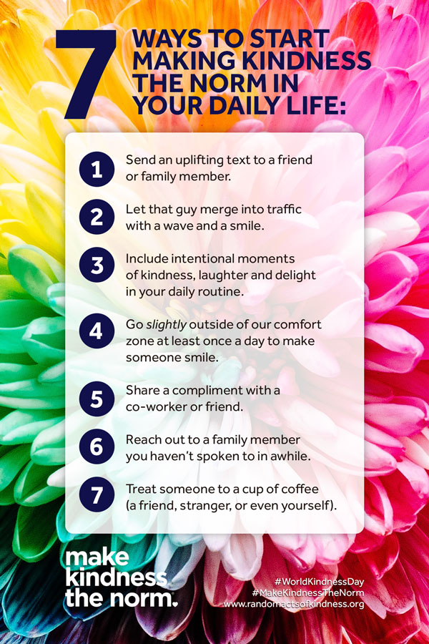
This years theme is ‘Random Acts of Kindness’ – an act with no expectation of reward or acknowledgement simply to make someone else’s day better.

Here are some examples of kind acts you can perform on Kindness Day or for a longer kindness initiative if you wanted to undertake that but remember the possibilities are infinite:
- Send a kind text to someone you know, this could be a thank you, well wish, compliment, remembrance of a kind deed or anything positive at all you wish to share!
- Say good morning to everyone on your way into work and good evening on your way home
- Sign up to the organ donor register or give blood
- Give someone a compliment – it could make their day, week or year!
- Go through your possessions and donate items you no longer use to charity
- Become a penfriend to someone less fortunate than you
- Send a thank you email to a friend or colleague
- Take the time to really listen to someone
- Share positive posts on your social media pages
- Cook a meal for friends or families and drop it at their doorstep
- Write positive reviews for places you have visited or businesses you have used
- Write a thank you letter to a teacher who stands out from your education

You can read many more ideas of random acts of kindness at http://kindnessuk.com/individuals.php
You can choose to do any or all the suggested activities below and your tutor will support you with any help you may need:
Question: how did this article make you feel? Click here to enter text.
Question: what is the kindest thing someone has done for you? What’s the most recent kind act that you’ve performed? Click here to enter text.
Research Online: read about the kindness challenge, what can you take part in? Click here to enter text.

COP26 Global Climate Summit
The Department for Education and the government have established Key Themes as specific topics that aim to enrich your learning by improving your wider skills and understanding above and beyond the course you are taking. Skills South Tyneside and your training provider want you to gain the most from your programme of learning and these activities will help to embed those Key Themes. The Key Themes are:
M-  Maths | E-  English | ILT- Information Learning Technology | EDI- Equality, Diversity Inclusion | S-  Safeguarding | P- Prevent | C-  Climate | HS- Health and Safety | BV-  British Values

This year will be the UN’s 26th Global Climate Summit, called COPs, which stands for Conference of the Parties, which will be hosted in Glasgow. Investing in the natural and built environment is one of our key priorities and the work South Tyneside Council is doing to become greener and more sustainable is central to that.

South Tyneside Council will be hosting a Climate Summit Week running from Monday 1st to Friday 5th November 2021. During the week there will be displays up in South Tyneside with information on what the Council is doing to tackle climate change and what you can do as a resident to play your part.

Pop into the venues to find out about the Council’s innovative ocean projects, renewable energy networks and habitat restoration schemes. You will be able to see the displays on sustainable travel options in Haven Point, Hebburn Central and Temple Park Centre.

Over the week, libraries across the Borough will be putting on a climate change book display. The displays will include a range of new, engaging fiction and non-fiction books with an environmental theme. A variety of new e-books and audio-books through Borrowbox are also available.

The Customs House will be hosting an exhibition called ‘Our Future World’, showcasing 36 posters drawn by primary school students across the Borough. As part of a COP26 competition, students were asked to create posters to reflect on how the world may look in 50 years’ time.

What we eat has a huge impact on our planet and is responsible for over 25% of global greenhouse gas emissions. This is because producing our food requires energy, land, water, and other resources. In general, pant-based (vegan) foods have a much smaller impact on the environment. Changing your diet can be a very effective way to help you tackle climate change. To learn more about the footprint of our food see Grantham Institute: Saving the Planet, one meal at a time. There will be free vegan items to try on the 4th and 5th of November at The Word Library and Haven Point cafés.

To see the full range of events available check out the COP Climate change Public Events page.
You can choose to do any or all the suggested activities below and your tutor will support you with any help you may need:
Question: what did you learn from this article? Click here to enter text.
Research Online: what does ‘food footprint’ mean? Click here to enter text.

