National Inclusion Week 2021
The Department for Education and the government have established Key Themes as specific topics that aim to enrich your learning by improving your wider skills and understanding above and beyond the course you are taking. Skills South Tyneside and your training provider want you to gain the most from your programme of learning and these activities will help to embed those Key Themes. The Key Themes are:
M-  Maths | E-  English | ILT- Information Learning Technology | EDI- Equality, Diversity Inclusion | S-  Safeguarding | P- Prevent | C-  Climate | HS- Health and Safety | BV-  British Values
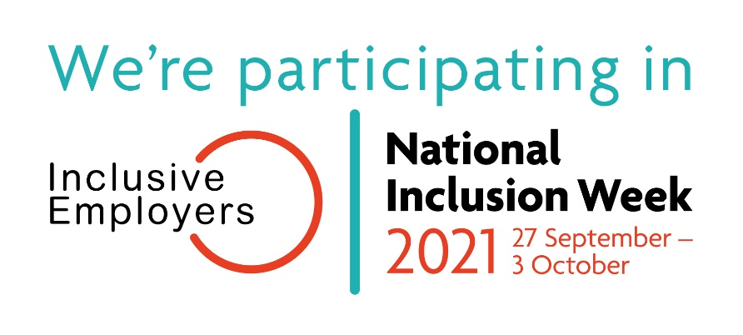
National Inclusion Week is an annual occurrence of workplace activities and events that highlight the importance of inclusion across the UK.

The theme for National Inclusion Week 2021 is #UnitedForInclusion

Valuing diversity and inclusion is important, and affects us all. It shouldn’t just be women who care about gender equality, or ethnic minorities and disabled people who care about inequality, or people from working class backgrounds who care about social mobility. Being in an inclusive culture is about everyone, and we all have a part to play.
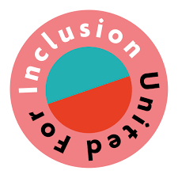
One of the British Values is mutual respect and tolerance of those with difference faiths and beliefs. By participating in National Inclusion Week you can actively champion that British Value in your place of study, your family or your workplace.

So how can we be more inclusive?
- Remember, there’s more that we have in common that what separates us, we all love our friends and family and we all want to our enjoy our lives.
- Always make sure that you’re using inclusive language when talking about minorities or different genders, making sure what we say doesn’t cause division but brings people together is important to make people feel equal.

- Challenge stereotypes when they happen as they can be an oversimplified idea of a person, for example, “women are housewives” - men can stay at home too.
- Avoid making comments about someone’s body or physical traits as this may make people feel uncomfortable.
- If you meet a disabled person, do not assume what they are or not able to do.

Finally, don’t be frightened of making a mistake, being inclusive is a process and it’s important to remain open and curious - continue looking for opportunities to learn about various topics that you’re unsure about and that way we can all be more inclusive to people in our community.
You can choose to do any or all the suggested activities below and your tutor will support you with any help you may need:
Question: what did you learn from this article? Click here to enter text.
Research Online: what activities can you do within your workplace, with friends or family, or with your classmates to take part in National Inclusion Week 2021? Click here to enter text.
Question: what are some common stereotypes that you may have faced in your life? Click here to enter text.

Climate Change – Scientists Are Freaked Out!
The Department for Education and the government have established Key Themes as specific topics that aim to enrich your learning by improving your wider skills and understanding above and beyond the course you are taking. Skills South Tyneside and your training provider want you to gain the most from your programme of learning and these activities will help to embed those Key Themes. The Key Themes are:
M-  Maths | E-  English | ILT- Information Learning Technology | EDI- Equality, Diversity Inclusion | S-  Safeguarding | P- Prevent | C-  Climate | HS- Health and Safety | BV-  British Values
This Summer, the world has seen weather that has shaken scientists. In every continent, records are being smashed by unprecedented margins. Climate projections are being outpaced, with extreme weather events happening more intensely, more frequently, and more widespread than most models had predicted. "Concerned scientists are no longer concerned - they are freaked out.” - Baroness Worthington, lead author on the UK's Climate Change Act.

In the past month, we have seen:
- The hottest temperature ever recorded on earth
In California, a global peak of 54.4°C was recorded. Russia, Mexico and New Zealand all experienced their hottest ever Junes. Temperature records in Canada were beaten by 4-5°C – a jump described as ‘mind-boggling’ by climatologists.
- Catastrophic flooding in Europe
Unprecedented flooding in Germany, the Netherlands and Belgium will cost over €2.55 billion in damages, with 228 confirmed deaths and 195 still missing.
- The first ever Extreme Heat Warning in the UK
The Met Office issued the heat warning, indicating potential adverse health effects and widespread disruption. Extreme heat in Southern England and Wales forced some pubs and restaurants to close as working conditions became unsafe for staff.
- Air 50% beyond safe breathing levels in New York
Smoke from wildfires 3,000 miles away left New York with the worst air quality in the world. Italy, France, Siberia, Cyprus, Turkey and the Lebanon have also experienced wildfires in the past month, and ‘very high risk’ warnings have been issued in Scotland and South West England.
- Golf ball-sized hailstones in Leicester
Car windscreens and greenhouses were destroyed, and golf courses damaged by ‘Day After Tomorrow-style’ hail in England. As well as this, July saw hospital evacuations in London due to flooding, a major typhoon in China, days after historic flooding, disastrous flooding in India and Bangladesh, and drought and famine in Madagascar.

The Good News: We Can Choose What Comes Next
We are already seeing some initial impacts of climate change. But we can choose what comes next. To better understand how you can help watch Episode 5 of The Breakdown: What You Can Do (8 minutes) or check out Nine Things You Can Do by Imperial College London.

Listen, Read & Watch
Listen to What Does Climate Change Sound Like? A Symphony
Read What Is the Environmental Impact of the Billionaire Space Race? and Charities call for ‘Amazon anti-waste law’ after firm denies destroying in-date food
Watch Footage: One Month of the Climate Crisis
Question: what have you learned from this article? Click here to enter text.
Research Online: according to the Imperial College London what can you do to tackle climate change? Click here to enter text.

ManHealth www.manhealth.org.uk
The Department for Education and the government have established Key Themes as specific topics that aim to enrich your learning by improving your wider skills and understanding above and beyond the course you are taking. Skills South Tyneside and your training provider want you to gain the most from your programme of learning and these activities will help to embed those Key Themes. The Key Themes are:
M-  Maths | E-  English | ILT- Information Learning Technology | EDI- Equality, Diversity Inclusion | S-  Safeguarding | P- Prevent | C-  Climate | HS- Health and Safety | BV-  British Values
ManHealth is an organisation that is building a network of male peer support groups across the United Kingdom helping men to manage and prevent Depression or other Mental Health Conditions. All ManHealth groups are facilitated by men with a lived experience of a mental health condition and they also offer a range of training courses on the health inequalities affecting men. Join their live webchat if you are a man who is struggling with their mental health. Open 7 nights a week 6-10pm.

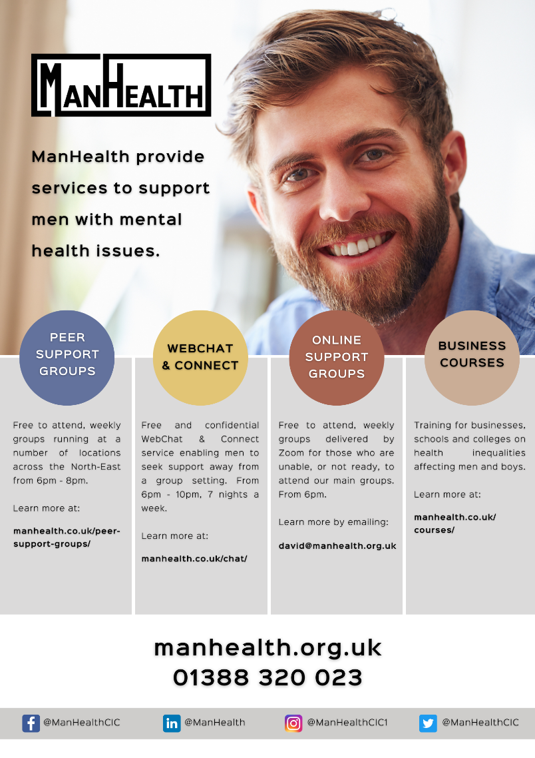
Question: how did this article make you feel? Click here to enter text.
Research Online: the suicide rate for men in England and Wales in 2019 was the highest for two decades. Data from the ONS found there were 5691 suicides registered. Why do you think working aged men account for the largest number of suicide deaths in the UK? Click here to enter text.

The English Language
The Department for Education and the government have established Key Themes as specific topics that aim to enrich your learning by improving your wider skills and understanding above and beyond the course you are taking. Skills South Tyneside and your training provider want you to gain the most from your programme of learning and these activities will help to embed those Key Themes. The Key Themes are:
M-  Maths | E-  English | ILT- Information Learning Technology | EDI- Equality, Diversity Inclusion | S-  Safeguarding | P- Prevent | C-  Climate | HS- Health and Safety | BV-  British Values


The English language really is beautiful, if not sometimes complicated. You have the love of an incredibly written book one minute and then you are trying to decipher the grammatical rules the next. In all of that there is always something to learn.

Check out these interesting facts that will hopefully inspire you to want to know more.

- Shakespeare invented over 1,000 words that are now a part of the English language. Some examples are – bedazzled, swagger, addiction and even the phrase ‘break the ice’.

- Most English words come from French or Old English (made up of Germanic vocabulary).

- There are an estimated 1 million words in the English language; the average English speaker only knows between 20,000 and 30,000. Proving there’s always plenty to learn.

- Although English is the most common language spoken in the U.S, technically there is no official language at federal level.

- The English language used to have a grammatical gender, similar to that of French where speakers use Le or La (the) depending on whether a noun is masculine or feminine. It’s a lot easier just having to remember a word meaning these days, and not its gender as well.

- Some of the oldest words in the English language are still used today. Black, mother, love and fire – many of these are thought to date back to before 900 AD.


- The English language use to have 29 letters instead of the current 26. One to go was Thorn: þ which was pronounced ‘th’. When Gothic script was introduced to Old English, the ‘y’ and ‘þ’ where thought to look too similar so one had to go.

You’ll need to be able to read, write or speak English for any job role you may need and all Skills South Tyneside funded courses will help you to improve your skills. You can find all of the courses we offer on our website.
You can choose to do any or all of the suggested activities below and your tutor will support you with any help you may need:
Question: what interests you about the English language?Click here to enter text.
Quick Activity: take the BBC Bitesize Grammar quiz, what was your score? Click here to enter text.

LGBT+ Training for South Tyneside Professionals
The Department for Education and the government have established Key Themes as specific topics that aim to enrich your learning by improving your wider skills and understanding above and beyond the course you are taking. Skills South Tyneside and your training provider want you to gain the most from your programme of learning and these activities will help to embed those Key Themes. The Key Themes are:
M-  Maths | E-  English | ILT- Information Learning Technology | EDI- Equality, Diversity Inclusion | S-  Safeguarding | P- Prevent | C-  Climate | HS- Health and Safety | BV-  British Values
Secure your place at a session by clicking here. Please note there is a cancellation charge of £5 if you cancel a course within 5 working days of the course running. For more information please click here.

