Climate Change – Plenty More Fish in the Sea?
The Department for Education and the government have established Key Themes as specific topics that aim to enrich your learning by improving your wider skills and understanding above and beyond the course you are taking. Skills South Tyneside and your training provider want you to gain the most from your programme of learning and these activities will help to embed those Key Themes. The Key Themes are:
M-  Maths | E-  English | ILT- Information Learning Technology | EDI- Equality, Diversity Inclusion | S-  Safeguarding | P- Prevent | C-  Climate | HS- Health and Safety | BV-  British Values
Our oceans’ health is deteriorating, along with the life within it. Human activity is causing rising temperatures, acidification, plastic and chemical pollution, and ecosystem destruction.
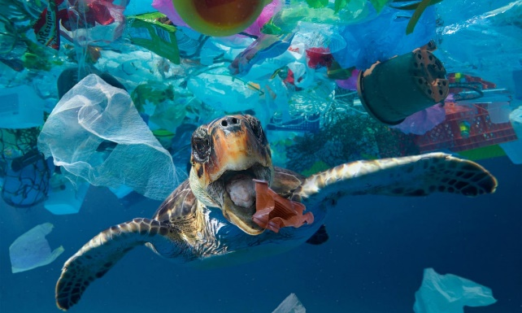
What’s the current picture:
- There are now 500x more microplastics in the ocean than stars in our galaxy.
- Oceans have reached record temperatures. In 2020 the world’s oceans absorbed 20 more Zettajoules of heat than in 2019 – equivalent to boiling 1.3 billion kettles.
- Around 35% of critical marine habitats have been destroyed.
- Humans have wiped out 90% of the ocean’s top predators in just 55 years.
Why should we care about ocean health?
- Healthy marine life provides 70% of the oxygen we breathe.
- The ocean controls our weather and, when out of balance, it causes increasingly unpredictable storms, flooding and droughts.
- Oceans contain up to 80% of all life on earth.
- Healthy oceans can provide 20% of the emissions reductions we need to avoid catastrophic climate change. Did you know, seagrass can capture carbon from the atmosphere 35 times faster than tropical rainforests?
- Polluted oceans can pollute our health. Toxic chemicals and microplastics are entering our food chain as they are ingested by marine life which end up on our plates.
So, how can we protect our oceans?
South Tyneside Council are partners in an innovative coastal project recently launched across the North East, which hopes to strengthen our relationships with the sea and stimulate communities to look after our natural world. To find out more about the Seascapes projects visit Explore SeaScapes.
As individuals, what worthwhile action can we take?
- Reducing our plastic consumption – plastics from take-outs and convenience food make up half of all ocean plastic and so are a good place to start. Try choosing packaging-free snacks and using refill shops and make sure to use everything you buy. Did you know, the UK is the third worst offender in Europe for littering our oceans?
- Consuming seafood sustainably – move from fish to shellfish like oysters and mussels as they can help capture some carbon. If we do eat fish, it’s important to opt only for those on the Good Fish Guide (to protect endangered species), to eat lower down the food chain (to maximise resource efficiency) and to choose line-caught fish (to avoid destructive trawling).
- Acting on climate change – if we embrace the benefits of walking and cycling more, wasting less energy and food, and holidaying in the UK, we can reduce our carbon footprint and protect our oceans from acidification, rising temperatures, biodiversity loss and pollution. Did you know that air pollution is responsible for 1/3 of the toxic contaminants that end up in our ocean?
Listen, Read, Watch
Listen to… BBC Monsters of the Deep Podcast
Read… Most couples may have to use assisted reproduction by 2045
Watch… Marsden Bay or Sandhaven Beach
Question: what have you learned from this article? Click here to enter text.
Research Online: what can be done to combat increasing ocean temperatures? Click here to enter text.

At Home Shouldn’t Mean At Risk #youarenotalone
The Department for Education and the government have established Key Themes as specific topics that aim to enrich your learning by improving your wider skills and understanding above and beyond the course you are taking. Skills South Tyneside and your training provider want you to gain the most from your programme of learning and these activities will help to embed those Key Themes. The Key Themes are:
M-  Maths | E-  English | ILT- Information Learning Technology | EDI- Equality, Diversity Inclusion | S-  Safeguarding | P- Prevent | C-  Climate | HS- Health and Safety | BV-  British Values
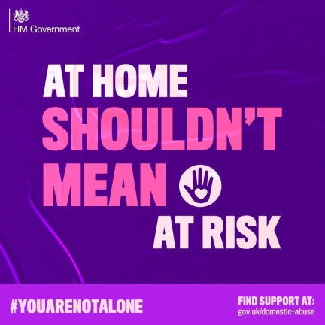
Coronavirus (COVID-19) has impacted everyone’s day to day to life but for a victim and their children experiencing or witnessing domestic abuse, the impact is significant. Social distancing and isolation has meant that victims and their children are sometimes left with the prospect of being isolated in their home with the perpetrator.

Now with restrictions easing victims are often experiencing anxiety about resuming normal social activities with perpetrators of abuse often exerting more violence to keep victims in their control.

Victims and their families are worried about accommodation, emotional wellbeing, negotiating child contact, accessing welfare benefits as well as their safety and that of their children.

South Tyneside Council and partners want to reassure you and your family that we’re still here and that services, although delivered differently, are still available. You still have options and we will do everything to help you.

Always remember that any abuse you experience is not your fault. If you’re a neighbour, friend or family member, and think someone might be at risk, please report your concerns or get advice from the services listed below:

If you are not in immediate danger, the following numbers might be helpful:
- Impact Family Services, 07375788835, www.impactfs.co.uk,
- Refuge (24 hr), 08082000247, www.refuge.org.uk,
- 24hr National Domestic Abuse Helpline, 0808 247 2000,
- LGBT+ Domestic Abuse Helpline, 08009995428, help@galop.org.uk,
- Men’s Advice Line, 08088010327, info@mensadvicelien.org.uk,
- Karma Nirvana (UK Helpline for ‘honour’ based abuse and forced marriage, 08005999247,
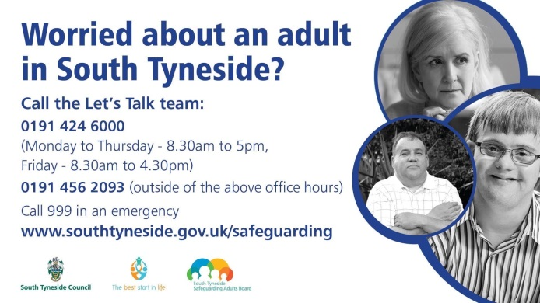
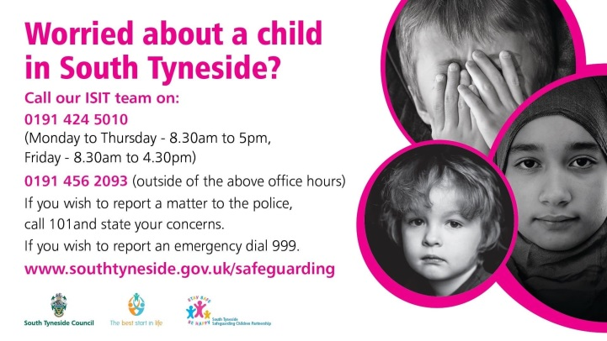
- Respect Helpline (for anyone worried about their own behaviour), 08088020321.
As always, if you or someone else is in immediate danger please call 999 and ask for the police.

Online Radicalisation and Extremism
The Department for Education and the government have established Key Themes as specific topics that aim to enrich your learning by improving your wider skills and understanding above and beyond the course you are taking. Skills South Tyneside and your training provider want you to gain the most from your programme of learning and these activities will help to embed those Key Themes. The Key Themes are:
M-  Maths | E-  English | ILT- Information Learning Technology | EDI- Equality, Diversity Inclusion | S-  Safeguarding | P- Prevent | C-  Climate | HS- Health and Safety | BV-  British Values
With more and more of us having spent increasing amounts of time in our homes due to COVID-19 the Police feel that this increases the risk of more people being radicalised online.

Counter Terrorism Policing North East are warning the public of potential dangers on the internet, as people increase their time online by working and learning from home. Young people are among those who have lost a significant part of their support network following the closure of schools and higher education establishments and some may have looked online for a replacement support network that they lost from having friends at school. Coupled with the uncertainty generated by the pandemic, they are potentially more vulnerable to negative influences and exploitation as they explore their concerns online, or seek distractions and interaction with others.


SPOTTING THE SIGNS
Individuals may be at risk to radicalisation for a variety of reasons, some of the most common signs include:
- isolating themselves from family and friends
- talking as if from a scripted speech
- unwillingness or inability to discuss their views
- a sudden disrespectful or intolerant attitude towards others
- increased levels of anger
- increased secretiveness, especially around their internet use


A campaign has been created to tackle the threat of online radicalisation. Coordinated by Prevent and with a focus on its “Let’s Talk About It” website https://www.ltai.info/, it is aimed at young and vulnerable people who could be at risk of being groomed by extremist individuals and groups online.

If you are worried about a friend, relative or even yourself, please go the Prevent “Let’s Talk About It” website https://www.ltai.info/ or if you have immediate concerns please contact 101 where you can access discreet and tailored support from a trained professional.

For local Prevent contacts you can speak with South Tyneside Council Community Safety Team on 0191 424 7935 or Northumbria Police Prevent Team on 101 ext. 63855.
You can choose to do any or all the suggested activities below and your tutor will support you with any help you may need:
Research Online: Between 2010 & 2018, 300,000 pieces of illegal terrorist material have been removed from the internet. Who you would report illegal material you find online to? Click here to enter text.
Question: Why are some young people drawn into ISIS or Far Right Extremism ideologies? Click here to enter text.

