Men’s Health Week 2021
The Department for Education and the government have established Key Themes as specific topics that aim to enrich your learning by improving your wider skills and understanding above and beyond the course you are taking. Skills South Tyneside and your training provider want you to gain the most from your programme of learning and these activities will help to embed those Key Themes. The Key Themes are:
M-  Maths | E-  English | ILT- Information Learning Technology | EDI- Equality, Diversity Inclusion | S-  Safeguarding | P- Prevent | C-  Climate | HS- Health and Safety | BV-  British Values

Men’s Health Week is celebrated each year as the week leading up to and including Father’s Day.

From the 14th-21st June the world celebrates Men’s Health Week. This is a time to bring awareness to health issues that affect men disproportionately and focuses on getting men to become aware of problems they may have, or could develop, and gain the courage to do something about it.

For 2020 the theme was 'Take Action on Covid-19'. For 2021, we'll be asking the question, when it comes to men, mental health and Covid-19, what next?


Men, Mental Health and Covid-19
Everybody's mental health has been challenged by the lockdowns and insecurities of the last year and it's not over. As we emerge from what we hope will be the worst of the pandemic, questions, concerns and anxieties remain. How do we move forward? Even before the pandemic, men's mental health was a cause for concern. There is a grave disparity in the high number of men who die from suicide and the low number of men who seek treatment for depression, anxiety and other mental health challenges.

Particular groups of male-dominated workforces have suffered disproportionately in terms of income and some (taxi drivers, for example) have received little support from government to compensate for this loss. Men are more likely to be in the sort of jobs that cannot easily be done from home with the result that many male-dominated workforces are also at greater risk from Covid-19.
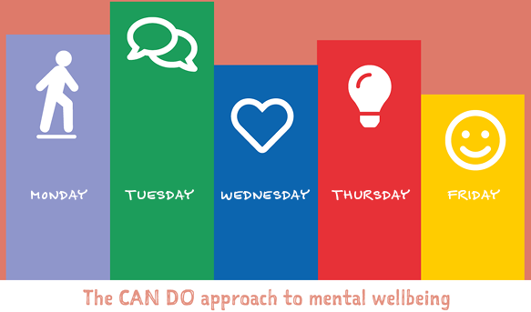
The CAN-DO challenge calls on everyone to try a different way to wellbeing each day of the Week.
Connect – call friends, family or colleagues and connect #connectMonday
Active – move your body by going for a run, swim or walk #activeTuesday
Notice – take notice of the environment around you by turning your phone off #noticeWednesday
Discover – learn something new by reading a book you haven’t read before #discoverThursday
Offer – do something for someone else, volunteer or give to charity #offerFriday

Find out more about The Five Ways to Wellbeing

Question: Why does society perceive men to be the stronger sex? Click here to enter text.
Research Online: How do you protect yourself from Covid-19? Click here to enter text.

International Women in Engineering Day – 23rd June 2021
The Department for Education and the government have established Key Themes as specific topics that aim to enrich your learning by improving your wider skills and understanding above and beyond the course you are taking. Skills South Tyneside and your training provider want you to gain the most from your programme of learning and these activities will help to embed those Key Themes. The Key Themes are:
M-  Maths | E-  English | ILT- Information Learning Technology | EDI- Equality, Diversity Inclusion | S-  Safeguarding | P- Prevent | C-  Climate | HS- Health and Safety | BV-  British Values

International Women in Engineering Day is an international awareness campaign to raise the profile of women in engineering and focus attention on the amazing career opportunities available to girls in this exciting industry. It celebrates the outstanding achievements of women engineers throughout the world.


Taking place annually on 23 June, it’s a day to get engineering‚ and girls (or women!) into the same sentence as often as possible, and to start to raise the profile of an engineering career as a great choice, with an exciting future, and amazing opportunities.

National Women in Engineering Day was launched for the first time in the UK on 23 June 2014 by the Women’s Engineering Society (WES) and since then the day has grown enormously over the subsequent years to the point where it received UNESCO patronage in 2016. In 2017, International Women in Engineering Day (INWED) was born to allow the celebration of women in engineering to become global.


The theme this year will be ‘Engineering Heroes’
This year the theme will celebrate the amazing work that women engineers around the world are doing not just to respond to the pandemic but also to support lives and livelihoods every day – the best and bravest women in engineering, who recognise a problem then dare to be part of the solution, who undertake everyday ‘heroics’ as much as emergency ones.

You can sign up to the newsletter or follow the weeks activities on Twitter and Instagram @INWED1919
You can also download the selfie card template here.
You can choose to do any or all the suggested activities below and your tutor will support you with any help you may need:
Question: 12.37% of all engineers in the UK are women. Why do you think this number is so low? Click here to enter text.
Question: what did you learn from this article? Click here to enter text.

Rethinking how we travel – addressing Climate Change
The Department for Education and the government have established Key Themes as specific topics that aim to enrich your learning by improving your wider skills and understanding above and beyond the course you are taking. Skills South Tyneside and your training provider want you to gain the most from your programme of learning and these activities will help to embed those Key Themes. The Key Themes are:
M-  Maths | E-  English | ILT- Information Learning Technology | EDI- Equality, Diversity Inclusion | S-  Safeguarding | P- Prevent | C-  Climate | HS- Health and Safety | BV-  British Values
As we live in a very car-centric society, we need to change the way we travel in order to tackle claim change. Here are some of the numbers about what this means for us and our environment:
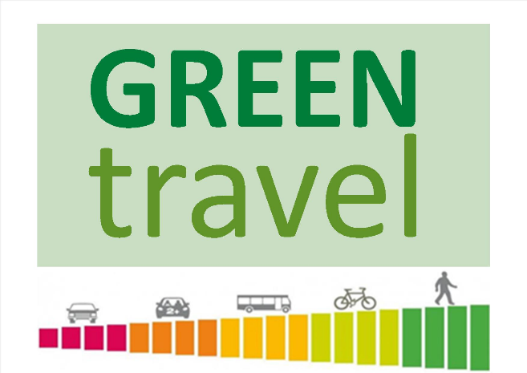
- Transport is currently responsible for about ¼ of the UKs greenhouse gas emissions
- Only 27% of trips are done by walking or cycling
- Hundreds of millions of car trips made every year in the UK are less than 1km, that’s a 10-minute walk
- Motor traffic is a major source of air pollution, linked to 36,000 early deaths a year in the UK
- Over 20,000 people per year are killed or seriously injured on our roads by motor vehicles
- Our inactivity contributes to the leading causes of death and ill health in the UK, including heart disease, stroke, breast cancer, colon cancer, diabetes and dementia
- Congestion in England will cost the British economy as much as £307 billion by 2030

This past year has opened the possibility of working from home and has encouraged us to stay local. As a result, we have seen huge reductions in carbon dioxide and other dangerous emissions, as well as changes in our urban areas. Our towns are quieter, air is cleaner, and more people are walking or cycling around their neighbourhoods. Compared to pre-pandemic levels, there has been a 20% rise in people walking regularly and cycling levels have increased by 9% on weekdays and 58% at weekends. We’ve caught a glimpse of how things can be. Now, we can keep up this momentum and change for the better.

One of the most effective and immediate ways to tackle transport emissions is to swap driving for cycling, e-biking or walking. This is known as active travel and is good environmentally, cheaper and healthier:
- Switching from driving to cycling for just one trip per day save the equivalent emissions of a flight from London to New York over the course of a year
- We would save the NHS £17billion within 20 years if the UK cycled as much as Denmark
- Cycling to work can save you over £3000 per year, with no fuel, insurance, tax or parking costs
- A 20-25-minute brisk daily walk can add 7 years to your life and cycling can give you the general health of someone 10 years younger
- Cycling reduces congestion, taking up 1/3 less road space and 8 times less parking space than cars
- Increasing sustainable travel could reduce road deaths by 30% by creating safer roads
- Walking and cycling help your core muscles and glutes, boost your immune system, improve your memory, and release endorphins, reducing anxiety and stress levels
Challenge yourself to a car-free day or week. Think about whether you can park halfway and walk the rest. If you do drive, drive smart.
Listen to… Feel Better, Live More Podcast – Making Movement Easier with Chris Boardman
Read… Bike to Work Guide
Watch… Animation – Which Mode of Transport Will Be First to Cross The Line?
You can choose to do any or all the suggested activities below and your tutor will support you with any help you may need:
True or False: Cycling for 30 minutes at a leisurely pace can burn 250 calories. Click here to enter text.
Question: What ways can you travel smarter or more actively? Click here to enter text.

