National Apprenticeships Week 8th – 14th February
The Department for Education and the government have established Key Themes as specific topics that aim to enrich your learning by improving your wider skills and understanding above and beyond the course you are taking. Skills South Tyneside and your training provider want you to gain the most from your programme of learning and these activities will help to embed those Key Themes. The Key Themes are:
M-  Maths | E-  English | ILT- Information Learning Technology | EDI- Equality, Diversity Inclusion | S-  Safeguarding | P- Prevent | C-  Climate | HS- Health and Safety | BV-  British Values

“Build the Future” is the theme for NAW2021, taking place between 8 and 14 February 2021, aiming to encourage everyone to consider how apprenticeships help individuals to build the skills and knowledge required for a rewarding career.
The 14th annual week-long celebration of apprenticeships, taking place across England, will showcase the impact apprenticeships can have on communities, local businesses and regional economies and how they all benefit from the impact of apprenticeships.
As a result of the pandemic and many individuals relying on technology and virtual meetings more than ever, National Apprenticeship Week 2021 will be different, but just as exciting. NAW2021 will celebrate the motivating stories of how apprentices have helped business adapt and build during a difficult year.
The week is a great opportunity to highlight the huge range of apprenticeships on offer – from Space Engineer to Registered Nurse. There are currently around 7,000 apprenticeship opportunities available on the Find An Apprenticeship website which will benefit individuals, businesses and local communities.
There’s also a programme of online activity open to employers, parents and potential apprentices and a couple are highlighted below. To find out more about what’s going on in South Tyneside there’s a dedicated webpage you can visit with case studies, resources and information on all events.
#AskTheApprentice | Monday 8th February | 17:00-18:00
We’ll be kicking off the week with an online social media takeover on Monday 8th February with apprentice Jordan Bell from Boldon based MB Air Systems who will answer your questions as well as talk about his experience of learning and earning. Submit your questions ahead of the event or join us live on the evening at: https://www.facebook.com/events/790955965104009/

Writing a Winning Application with ASK | Tuesday 9th February | 10:00 – 11:00
If you’re thinking about an apprenticeship and want to ensure you’ve got the best chance of impressing an employer, this live and interactive session is for you. We’ll unpick what an employer looks for on an application and how you can best sell your skills to give yourself the best chances of an interview. This is an online event via Microsoft Teams which you can join HERE.
To find out more about NAW in South Tyneside and to get involved, contact: alex.whelan@southtyneside.gov.uk

LGBT+ History Month 2021
The Department for Education and the government have established Key Themes as specific topics that aim to enrich your learning by improving your wider skills and understanding above and beyond the course you are taking. Skills South Tyneside and your training provider want you to gain the most from your programme of learning and these activities will help to embed those Key Themes. The Key Themes are:
M-  Maths | E-  English | ILT- Information Learning Technology | EDI- Equality, Diversity Inclusion | S-  Safeguarding | P- Prevent | C-  Climate | HS- Health and Safety | BV-  British Values
LGBT History Month is celebrated every February in the UK.

What is LGBT History Month?
LGBT History Month is a month-long annual observance of lesbian, gay, bisexual and transgender history, and the history of the gay rights and related civil rights movements. The aim of the month is to increase the visibility of LGBT+ people, their history, lives and their experiences in the curriculum and culture of education and the wider community, raise awareness and advancing education on matters affecting LGBT+ communities, and promoting the welfare of LGBT+ people to achieve their full potential, so they contribute fully to society and lead fulfilled lives thus benefiting society as a whole.

LGBT+ Terminology
Everyone has the right to self-identify and will have differing relationships with the words that they choose to identify themselves with. It is important to ask how a person identifies themselves, and to respect their answer. You can find a glossary of LGBT+ terms here to help you to fully understand .

A selection of presentations celebrating LGBT+ History are available as part of the Outing the Past 2021 Festival.

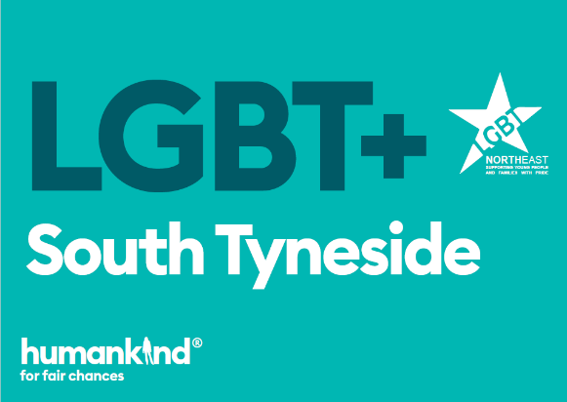
Humankind are delivering a specialist LGBT+ (Lesbian, Gay, Bisexual, Transgender or other related identities) Support Service for young people aged 11 to 25 years across South Tyneside. The service will provide a co-produced one to one support offer; family work; peer support networks and workshops. In addition, the service will work with core organisations operating in South Tyneside to improve LGBT+ awareness. Humankind are also working with schools to provide the partnership scheme, The Rainbow Flag Award, to promote LGBT+ inclusivity.
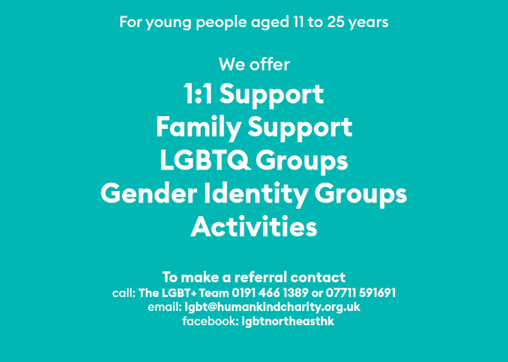

Considering COVID – 19, Humankind are looking at new and innovative ways to ensure LGBT+ Young People receive the same level of care and support. One to one appointments, assessments & peer support groups can all be offered virtually via a number of agreed platforms meaning Young People will be able to speak face to face to our LGBT+ Senior Practitioner.

The service email is lgbt@humankindcharity.org.uk or call 0191 466 1389.
You can choose to do any or all the suggested activities below and your tutor will support you with any help you may need:
Question: What is gender identity? Click here to enter text.
Research Online: In 2018 what percent of people identified as LGB? Click here to enter text.
Question: What words or identities might be represented by the “+”? Click here to enter text.

Financial Awareness and Support
The Department for Education and the government have established Key Themes as specific topics that aim to enrich your learning by improving your wider skills and understanding above and beyond the course you are taking. Skills South Tyneside and your training provider want you to gain the most from your programme of learning and these activities will help to embed those Key Themes. The Key Themes are:
M-  Maths | E-  English | ILT- Information Learning Technology | EDI- Equality, Diversity Inclusion | S-  Safeguarding | P- Prevent | C-  Climate | HS- Health and Safety | BV-  British Values

With the ongoing COVID-19 pandemic and lockdown continuing the impact on personal finances for some has been significant. A 2010 study from the Royal College of Psychiatrists found that half of UK adults in problem debt are also living with mental ill-health. These ranged from a consistent feeling of anxiety and low moods, to diagnosed mental health disorders. Experiencing a mental health issue does not automatically mean that you are unable to manage your money or deal with your debts, but it can make it more difficult. It is better to get advice on dealing with your debts as soon as possible using the resources provided below.

Review your Budget
Whenever you think your financial situation may be uncertain it’s a good idea to review your income and spending. List your income and spending and you’ll be able to clearly see how much money you’ve got coming in and how much money you’ve got going out. Cutting your spending is much easier if you know exactly where your money goes each month. The Money Advice Service website if you want help drawing up a detailed breakdown of your spending.

Check your Entitlement to Benefits

If you can’t work because you’re sick, must self-isolate, you’ve lost your job or your income has dropped significantly, there are a number of benefits you may be eligible for. These could include Universal Credit, Statutory Sick Pay or Employment and Support Allowance. There is also support available if you need help with childcare, housing or council tax costs. The national charity Turn2Us has details of state benefits and other grants available on its website plus a benefits calculator to help you work out what benefits you may be eligible for.

Check for Additional Government Help
Visit the government website for all the latest news and information on what help and support the government is offering during the coronavirus pandemic. This includes information on employment, financial support, health & wellbeing and working safely.

Help is available for anyone dealing with problem debt and the anxiety it can cause. Shelter, Citizens Advice Bureau Debt Management and Debt Support Trust all offer a free advice service. Stepchange have a free online advice service and you can also call 0800 138 1111. The National Debtline also has a free helpline on 0800 808 4000 and you can use their webchat for any help or advice.

Martin Lewis at Money Saving Expert has produced a Mental Health and Debt free PDF booklet guide.
You can choose to do any or all the suggested activities below and your tutor will support you with any help you may need:
Question: How did this article make you feel? Click here to enter text.
Question: The Citizens Advice Bureaux in England and Wales dealt with 1,767 debt issues every day in 2020. How many is this over the year? Click here to enter text.

