Notice Check Share – Prevent Agenda
The Department for Education and the government have established Key Themes as specific topics that aim to enrich your learning by improving your wider skills and understanding above and beyond the course you are taking. Skills South Tyneside and your training provider want you to gain the most from your programme of learning and these activities will help to embed those Key Themes. The Key Themes are:
M-  Maths | E-  English | ILT- Information Learning Technology | EDI- Equality, Diversity Inclusion | S-  Safeguarding | P- Prevent | C-  Climate | HS- Health and Safety | BV-  British Values
Prevent is part of the UKs counter terrorism strategy, preventing people from becoming involved with or supporting terrorism. Radicalisation is defined as the process where someone had their vulnerabilities or susceptibilities exploited towards crime of terrorism – most often by a third party who have their own agenda.
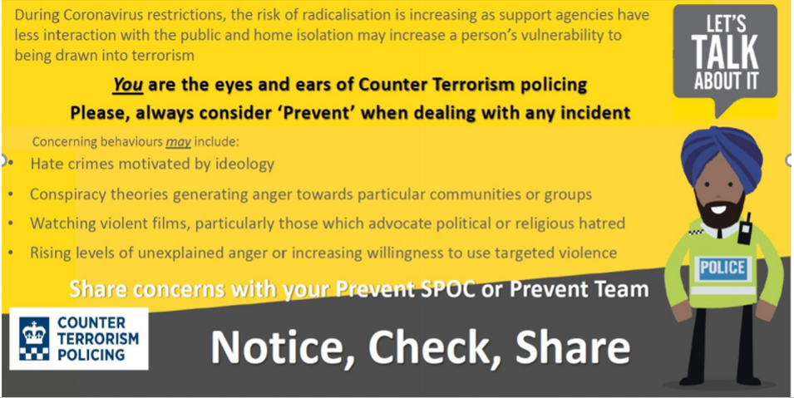

The Police are urging all of us to be vigilant against the threat of online radicalisation during the COVID-19 pandemic and remembering ‘Notice Check Share’ may help you if you know of someone who may be at risk.
- Notice – if you notice something of concern
- Check – check your concern and ask the opinion of your tutor, manager or someone you trust to see if they agree
- Share – share the concern if you/your trusted person feel that it is warranted.

If you are worried about a friend, relative or even yourself, please go to the Prevent “Let’s Talk About It” website or if you have immediate concerns please contact 101 where you can access discreet and tailored support from a trained professional.

For local Prevent contacts you can speak with South Tyneside Council Community Safety Team on 0191 424 7935 or Northumbria Police Prevent Team on 101 ext. 63855.
You can choose to do any or all the suggested activities below and your tutor will support you with any help you may need:
Question: what did you learn from this article?
Click here to enter text.
Research Online: Why are young people drawn into ISIS or Far Right Extremism ideologies?
Click here to enter text.

Working or Learning from Home – Supporting Your Mental Health
The Department for Education and the government have established Key Themes as specific topics that aim to enrich your learning by improving your wider skills and understanding above and beyond the course you are taking. Skills South Tyneside and your training provider want you to gain the most from your programme of learning and these activities will help to embed those Key Themes. The Key Themes are:
M-  Maths | E-  English | ILT- Information Learning Technology | EDI- Equality, Diversity Inclusion | S-  Safeguarding | P- Prevent | C-  Climate | HS- Health and Safety | BV-  British Values
2020 has seen people working and learning from home more than ever before to help combat the global COVID-19 pandemic but with the convenience that comes with not having a commute, there are also potential challenges to home-working such as feelings of isolation, mental health problems and not feeling connected with colleagues or classmates. Here are some ways to help combat some of the negatives you may experience:

GET SET UP
Waking up – although you may have some extra time in bed without a commute, aim to set you alarm for the same time every day.
Get dressed – keeping your behaviours the same as if you were going into work or the classroom (such as getting up, washed and dressed) will help you to get into the work mindset. Set up your workspace – try to set aside a workspace that is separate from your sleeping area which will help you switch off at the end of each day. This routine will help stabilise your internal clock and improve your sleep overall making you feel less tired, more refreshed and you’ll find it easier to concentrate through the day too.
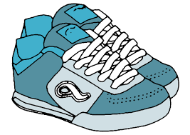
GET MOVING
Including some movement into your work/learn from home routine will help maintain your physical and mental health. You’ll feel more awake and alert, and your concentration and sleep will improve. Outdoors – if you’re not self-isolating, try going for a walk or a jog down the street before you start work for the day – this can help you feel like you have ‘mentally’ commuted. Indoors – try looking online for an activity that suits you, such as a home yoga vide or a fitness class. Some gyms are even live streaming their classes so you can join in with others in your community.


GET CONNECTED
Adapt your working style – make sure you’re keeping open communication as often and frequently as possible with others. Try video calling instead of email or do a quick check-in with team members or classmates. Virtual social sessions – try turning your morning or afternoon break into a virtual coffee break and catch up with others, share photo updates of your interests or hobbies or do a daily quick online.

GET SUPPORT
Look after yourself and set aside time to prioritise self-care – all of the above tips will help as well setting time aside for fun, learning new skills, sharing how you’re feeling, avoid over-working and overdoing it on sugar, caffeine or alcohol. For more information about mental health and coronavirus CLICK HERE: and HERE

Mental health helpline Samaritans offers free, confidential support 24 hours a day on 116 123.
Find a list of national mental health services and helplines HERE
You can choose to do any or all the suggested activities below and your tutor will support you with any help you may need:
Question: What can you do personally to improve your working/learning from home experience?
Click here to enter text.
Research Online by Clicking HERE: In April 2020 what percent of people in employment did some work from home? Of those who did some work from home, what percent did so as a result of COVID-19?
Click here to enter text.

Religious Festivals in December – Celebrating Safely
The Department for Education and the government have established Key Themes as specific topics that aim to enrich your learning by improving your wider skills and understanding above and beyond the course you are taking. Skills South Tyneside and your training provider want you to gain the most from your programme of learning and these activities will help to embed those Key Themes. The Key Themes are:
M-  Maths | E-  English | ILT- Information Learning Technology | EDI- Equality, Diversity Inclusion | S-  Safeguarding | P- Prevent | C-  Climate | HS- Health and Safety | BV-  British Values
A religious festival is a time of special importance marked by followers of that particular religion. Religious festivals are commonly celebrated on recurring cycles in a calendar year or lunar calendar. Religion and festival go together. Hundreds of very different religious festivals are held around the world each year.
Below are the festivals that are celebrated during December:
- 8th Bodhi Day Hanukkah - Buddhist festival celebrating Gautama's attainment of enlightenment.
- 11th – 18th - Jewish festival that celebrates victory over religious persecution.
- 21st Yule - Pagan festival that marks the winter solstice when the sun child is reborn.
- 25th Christmas Day - Christian festival that celebrates the birth of Christ.
- 26th St Stephen's Day - Christian festival celebrates the first Christian martyr.
- 31st Omisoka – Japanese festival which prepares for the new year by cleansing Shinto home shrines and Buddhist altars.
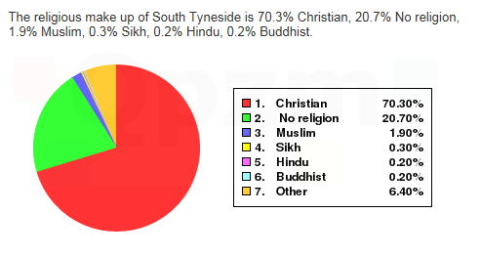
Want to learn more? Just click this link to a publication by The Independent
Religious statistics for our area:
8,616 people did not state a religion. 379 people identified as a Jedi Knight and 5 people said they believe in Heavy Metal.
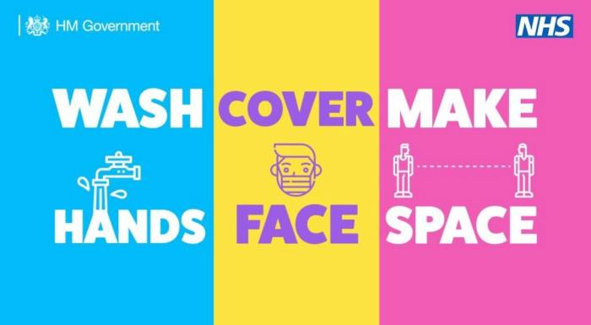
The Government has agreed that up to three households can form a Christmas bubble and meet up from 23rd to 27th December. People can mix in homes, places of worship and outdoor spaces, and travel restrictions will be eased. However, a Christmas bubble must be exclusive, so people cannot swap between them. Bubble members will also not be able to visit pubs or restaurants together. There will be no limit to the number of people in a household joining a bubble. Remember, although household bubbles are allowed you should still try to stay as safe as possible by keeping 2 metres apart wherever possible, regularly washing your hands and if space isn’t possible wear a face covering.
You can choose to do any or all the suggested activities below and your tutor will support you with any help you may need:
Question: What is the combined percentage of all other religions in South Tyneside other than Christian and no religion? Click here to enter text.
Research Online: research Hanukkah, what have you learned about the religious holiday? Click here to enter text.

Human Rights Day 2020 – 10th December
The Department for Education and the government have established Key Themes as specific topics that aim to enrich your learning by improving your wider skills and understanding above and beyond the course you are taking. Skills South Tyneside and your training provider want you to gain the most from your programme of learning and these activities will help to embed those Key Themes. The Key Themes are:
M-  Maths | E-  English | ILT- Information Learning Technology | EDI- Equality, Diversity Inclusion | S-  Safeguarding | P- Prevent | C-  Climate | HS- Health and Safety | BV-  British Values
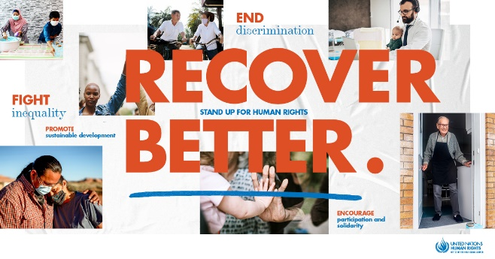
Human Rights Day is observed every year on 10 December — the day the United Nations General Assembly adopted, in 1948, the Universal Declaration of Human Rights (UDHR): a milestone document proclaiming the inalienable rights which everyone is inherently entitled to as a human being regardless of race, colour, religion, sex, language, political or other opinion, national or social origin, property, birth or other status. Available in more than 500 languages, it is the most translated document in the world.

2020 Theme: Recover Better – Stand Up for Human Rights
This year’s Human Rights Day theme relates to the COVID-19 pandemic and focuses on the need to build back better by ensuring Human Rights are central to recovery efforts. We will reach our common global goals only if we are able to create equal opportunities for all, address the failures exposed and exploited by COVID-19, and apply human rights standards to tackle entrenched, systematic, and intergenerational inequalities, exclusion and discrimination.

Human Rights must be at the centre of the post COVID-19 world
The COVID-19 crisis has been fuelled by deepening poverty, rising inequalities, structural and entrenched discrimination and other gaps in human rights protection. Only measures to close these gaps and advance human rights can ensure we fully recover and build back a world that is better, more resilient, just, and sustainable.
End discrimination of any kind: Structural discrimination and racism have fuelled the COVID-19 crisis. Equality and non-discrimination are core requirements for a post-COVID world.
Address inequalities: To recover from the crisis, we must also address the inequality pandemic. For that, we need to promote and protect economic, social, and cultural rights. We need a new social contract for a new era.

Encourage participation and solidarity: We are all in this together. From individuals to governments, from civil society and grass-roots communities to the private sector, everyone has a role in building a post-COVID world that is better for present and future generations. We need to ensure the voices of the most affected and vulnerable inform the recovery efforts.
Promote sustainable development: We need sustainable development for people and planet. Human rights, the 2030 Agenda and the Paris Agreement are the cornerstone of a recovery that leaves no one behind.
You can choose to do any or all the suggested activities below and your tutor will support you with any help you may need:
Question: What did you learn from this article? Click here to enter text.
Question: How long has the Universal Declaration of Human Rights (UDHR) been in place? Click here to enter text.
Research Online by Clicking HERE: What is structural discrimination and racism and how has this fuelled the COVID-19 crisis? What can we all do personally to combat structural racism? Click here to enter text.

