Remembrance Sunday (November 8th)
The Department for Education and the government have established Key Themes as specific topics that aim to enrich your learning by improving your wider skills and understanding above and beyond the course you are taking. Skills South Tyneside and your training provider want you to gain the most from your programme of learning and these activities will help to embed those Key Themes. The Key Themes are:
M-  Maths | E-  English | ILT- Information Learning Technology | EDI- Equality, Diversity Inclusion | S-  Safeguarding | P- Prevent | C-  Climate | HS- Health and Safety | BV-  British Values
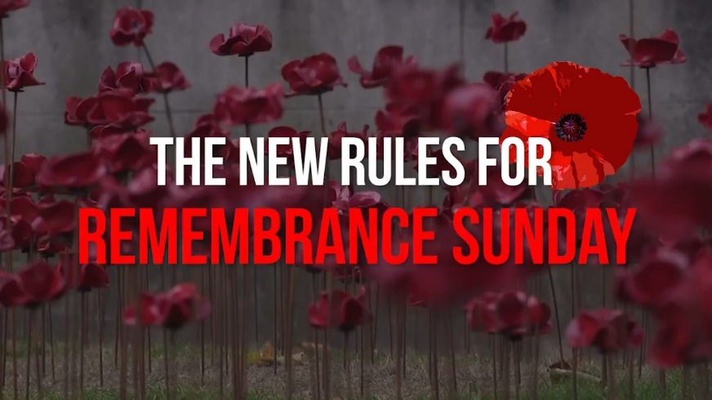
Remembrance Sunday is observed as a commemoration of the contribution of British and Commonwealth military and civilian servicemen and women in the two World Wards and later conflicts. Observances include wearing of poppies, wreaths of remembrance poppies being laid on memorials and a two-minute silence at 11am.
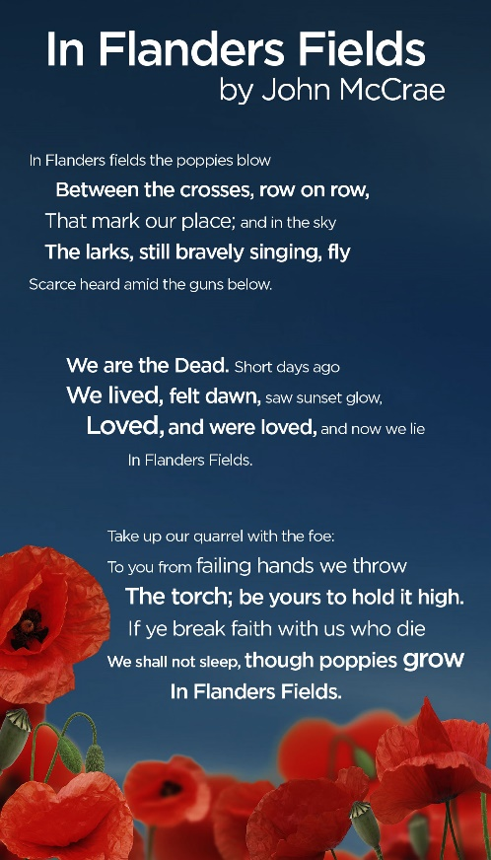
This years Remembrance Sunday is going to be different due to the COVID-19 pandemic and the need for social distancing. For the first time in its 100-year history members of the public will be barred from the Cenotaph wreath-laying, while community Royal British Legion parades throughout the UK have been cancelled. England’s three-tier alert level system provides an exemption for Remembrance Sunday events, but social distancing will limit public commemoration.

A campaign has been launched to commemorate the day safely, and pay our respects, by standing on our doorsteps at 11am on Remembrance Sunday to mark the two-minute silence. This campaign has the backing of the Royal British Legion and the Government with Prime Minister Boris Johnson saying “the pandemic will not stop us from honouring the sacrifice and valour of our veterans, the bravest of the brave, the best of what it means to be British.”. Labour leader Sir Keir Starmer added: “Remembrance Sunday is our chance as a nation to stand together to remember the millions of people from across the United Kingdom, and from across the world, who sacrificed so much to keep us safe. In normal times, we would be paying tribute to our armed forces at the Cenotaph or at events organised by the Royal British Legion. This year we cannot do that – this year we cannot stand together but, we can still pay our respects by standing on our doorstops at 11am on Remembrance Sunday.”
You can choose to do any or all the suggested activities below and your tutor will support you with any help you may need:
Question: what did you learn from this article? Click here to enter text.
Question: why are poppies the symbol of Remembrance Sunday? Click here to enter text.

World Kindness Day – November 13th #makekindnessthenorm #worldkindnessday
The Department for Education and the government have established Key Themes as specific topics that aim to enrich your learning by improving your wider skills and understanding above and beyond the course you are taking. Skills South Tyneside and your training provider want you to gain the most from your programme of learning and these activities will help to embed those Key Themes. The Key Themes are:
M-  Maths | E-  English | ILT- Information Learning Technology | EDI- Equality, Diversity Inclusion | S-  Safeguarding | P- Prevent | C-  Climate | HS- Health and Safety | BV-  British Values
World Kindness Day is a global day that promotes the importance of being kind to each other, to yourself and to the world. This day, celebrated on November 13th of each year, has the purpose of helping everyone understand that compassion for others is what binds us all together. This understanding has the power to bridge the gap between race, religion, gender or sexual orientation.

This years theme is Random Acts of Kindness – an act with no expectation of reward or acknowledgement simply to make someone else’s day better.

Here are some examples of kind acts you can perform on Kindness Day or for a longer kindness initiative if you wanted to undertake that but remember the possibilities are infinite:
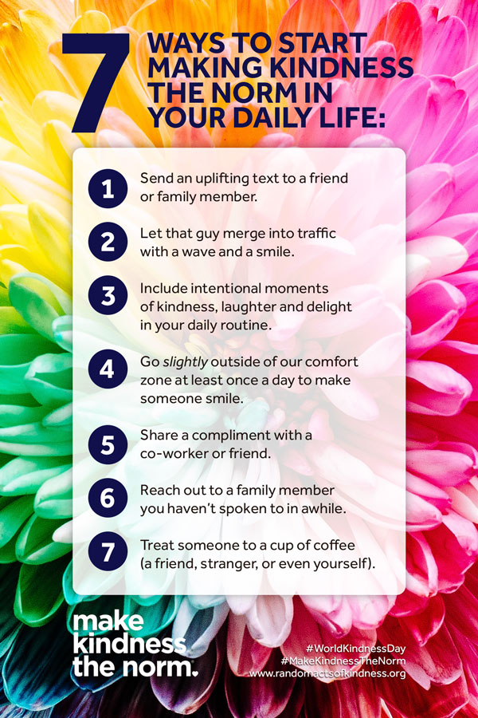
- Send a kind text to someone you know, this could be a thank you, well wish, compliment, remembrance of a kind deed or anything positive at all you wish to share!
- Say good morning to everyone on your way into work and good evening on your way home
- Sign up to the organ donor register or give blood
- Give someone a compliment – it could make their day, week or year!
- Go through your possessions and donate items you no longer use to charity
- Become a pen-friend to someone less fortunate than you
- Send a thank you email to a friend or colleague
- Take the time to really listen to someone
- Share positive posts on your social media pages
- Cook a meal for friends or families and drop it at their doorstep
- Write positive reviews for places you have visited or businesses you have used
- Write a thank you letter to a teacher who stands out from your education

You can read many more ideas of random acts of kindness at http://kindnessuk.com/individuals.php
You can choose to do any or all the suggested activities below and your tutor will support you with any help you may need:
Question: how did this article make you feel? Click here to enter text.
Question: What is the kindest thing that someone has done for you? What’s the most recent kind act that you’ve performed? Click here to enter text.
Question: Read about the kindness challenge at https://www.randomactsofkindness.org/get-inspired what can you take part in? Click here to enter text.

Free Mental Health Support and Training in South Tyneside Available to All
The Department for Education and the government have established Key Themes as specific topics that aim to enrich your learning by improving your wider skills and understanding above and beyond the course you are taking. Skills South Tyneside and your training provider want you to gain the most from your programme of learning and these activities will help to embed those Key Themes. The Key Themes are:
M-  Maths | E-  English | ILT- Information Learning Technology | EDI- Equality, Diversity Inclusion | S-  Safeguarding | P- Prevent | C-  Climate | HS- Health and Safety | BV-  British Values
Mental Health Support for Men in South Tyneside
In response to the COVID-19 situation, ManHealth are piloting a new live chat and connect service for South Tyneside residents via this web page from 5-7pm each evening, starting 27th April. Men experiencing mental health issues can chat in confidence with one of our trained group leaders to get support and find out about ManHealth peer support groups in the area. Click the links below to get in touch if you are a man in South Tyneside seeking support or if you are a support worker wishing to refer a client. ManHealth is funded by Public Health in South Tyneside. www.manhealth.org.uk/styne www.manhealth.org.uk
Mental Health Action and Awareness
Bringing Our Community Together to Fight Mental Health Distress During COVID-19
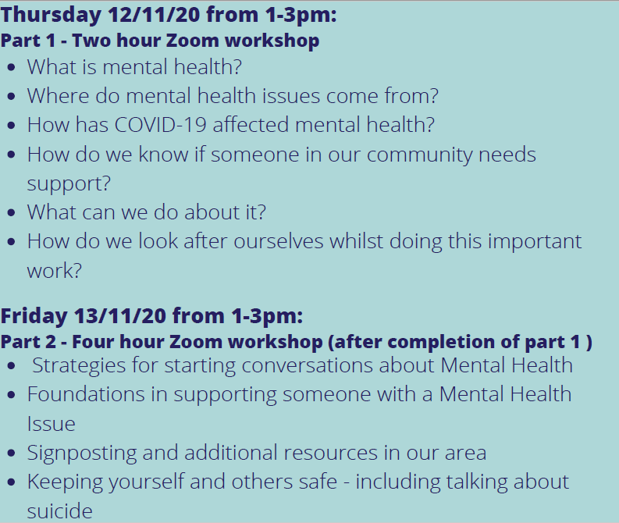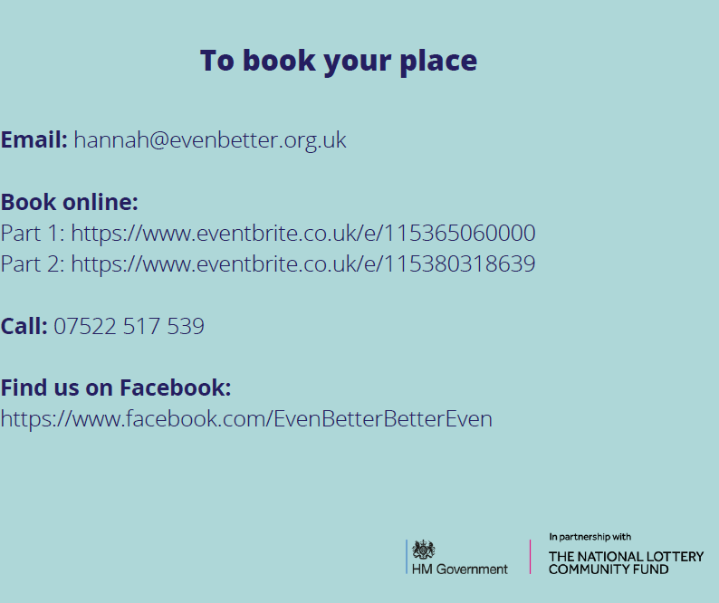
Virtual Emotional Health and Wellbeing Awareness Training & Online Suicide Prevention Training
