A COVID-19 Secure Halloween
The Department for Education and the government have established Key Themes as specific topics that aim to enrich your learning by improving your wider skills and understanding above and beyond the course you are taking. Skills South Tyneside and your training provider want you to gain the most from your programme of learning and these activities will help to embed those Key Themes. The Key Themes are:
M-  Maths | E-  English | ILT- Information Learning Technology | EDI- Equality, Diversity Inclusion | S-  Safeguarding | P- Prevent | C-  Climate | HS- Health and Safety | BV-  British Values
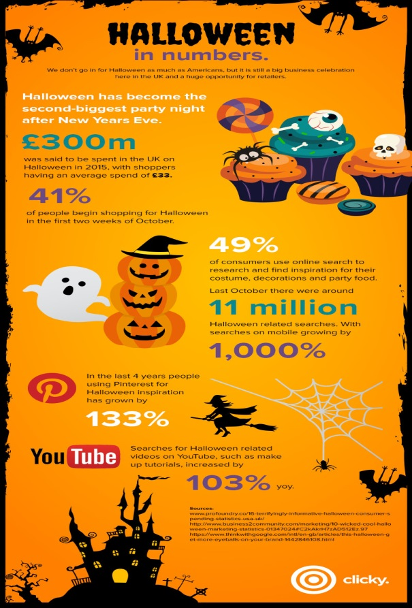
Halloween or Hallowe'en, also known as All Hallows' Eve, or All Saints' Eve, is a celebration observed in several countries on 31 October, the eve of the Western Christian feast of All Hallows' Day. It begins the three-day observance of Allhallowtide, the time in the year dedicated to remembering the dead, including saints, martyrs, and all the faithful departed.

Trick-or-treating is a customary celebration for children on Halloween where children go door-to-door collecting ‘treats’ in the form of sweets but this year that could be high-risk for spreading COVID-19. There are several, safer alternative ways to participate In Halloween.

Activities for a COVID-19 Secure Halloween
- Carving or decorating pumpkins with members of your household and displaying them.
- Decorating your house.
- Do a Halloween scavenger hunt where children are given lists of Halloween-themed things to look for while they walk outdoors admiring decorations at a distance.
- Have a virtual Halloween costume contest.
- Have a Halloween film night at home.
- Statistics show that on Halloween, children between the ages of 5 and 14 are four times more likely to be killed by a car than any other day of year. This is even increased due to alcohol related crimes. Carry glow sticks or flashlights, use reflective tape or stickers on costumes and bags, and wear light colors to help kids see and be seen by drivers.
- Slow down and be alert! Children are excited on Halloween and may dart into the street. Turn on headlights early in the day to spot children from further away.

You can choose to do any or all the suggested activities below and your tutor will support you with any help you may need:
Question: If £300 million was spent in 2015, presuming this figure has increased by 10% per year, how much would we predict would be spent in 2020? Click here to enter text.
Research Online: Read the article: https://www.healthychildren.org/English/health-issues/conditions/COVID-19/Pages/Halloween-COVID-Safety-Tips.aspx What ways can you celebrate Halloween differently this year to stay safe? Click here to enter text.
True or False: The first Jack-O-Lanterns were originally turnips. Click here to enter text.

Growth Mindset – How Can it Help You?
The Department for Education and the government have established Key Themes as specific topics that aim to enrich your learning by improving your wider skills and understanding above and beyond the course you are taking. Skills South Tyneside and your training provider want you to gain the most from your programme of learning and these activities will help to embed those Key Themes. The Key Themes are:
M-  Maths | E-  English | ILT- Information Learning Technology | EDI- Equality, Diversity Inclusion | S-  Safeguarding | P- Prevent | C-  Climate | HS- Health and Safety | BV-  British Values
What is Growth Mindset?
Psychologist Carol Dweck states that your mindset can determine a person’s success in any situation whether it be in learning, family life, work or health. Using her research, she identified that there are two main mindsets which we would consider to be our personality. A ‘fixed’ mindset assumes that our character, intelligence and creative abilities are all set in stone and can’t be changed in any meaningful way and therefore any success we achieve (or not) is not in our control, but merely down to our talent (or lack therefore). The ‘growth’ mindset is where individuals believe their talents can be developed through hard work, good strategies, practice and input from others. People with a growth mindset tend to achieve more than those with a fixed mindset because they worry less about looking smart and they put more energy into learning.
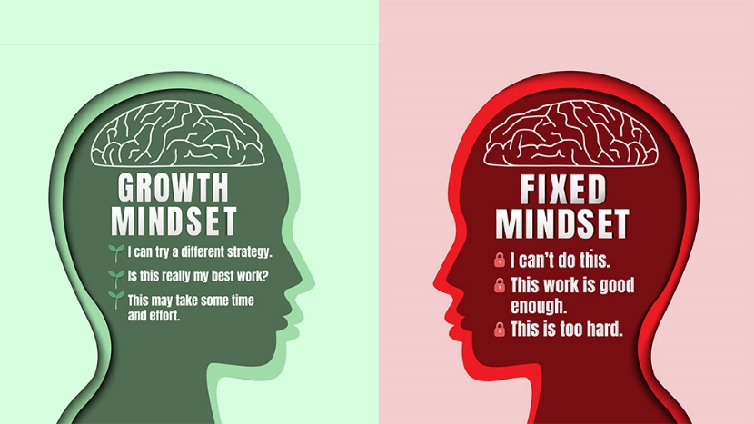
Advantages of a Growth Mindset
Research has linked growth mindset with lots of benefits including:
- Greater comfort taking risks
- Striving for more challenging goals
- Higher motivation
- Enhanced brain development across a wider range of tasks
- Lower stress, anxiety and depression
- Better work relationships
- Higher performance levels

How to Develop a Growth Mindset
There’s clearly lots of advantages to having a growth mindset that will help you in achieving more in learning, your work life and your personal life so how can you change your mindset to a growth mindset?
- Acknowledge and embrace imperfections – hiding from your weaknesses means you’ll never overcome them.
- Try different learning tactics. There’s no one-size-fits-all model for learning and what works for one person may not work for you. Speak with your tutor who will help support you with different ways that you can learn.
- Replace the word ‘failing’ with the word ‘learning’ – when you make a mistake or fall short of a goal, you haven’t failed; you’ve learned!
- Look at criticism as a positive – what can you learn from it? What can you do differently next time?
- Look for regular opportunities for reflection – reflect on your learning at least once a day and remind yourself that learning is brain training. The brain is like a muscle that needs to work out just like your body!
You can choose to do any or all the suggested activities below and your tutor will support you with any help you may need:
Question: what did you learn from this article? Click here to enter text.
Research Online: read the article on https://www.teachthought.com/learning/25-simple-ways-develop-growth-mindset/. What can you do personally to change your mindset? Click here to enter text.
Question: Do you consider yourself to have a fixed mindset or a growth mindset about your learning? Click here to enter text.

World Mental Health Day – 10th October 2020
The Department for Education and the government have established Key Themes as specific topics that aim to enrich your learning by improving your wider skills and understanding above and beyond the course you are taking. Skills South Tyneside and your training provider want you to gain the most from your programme of learning and these activities will help to embed those Key Themes. The Key Themes are:
M-  Maths | E-  English | ILT- Information Learning Technology | EDI- Equality, Diversity Inclusion | S-  Safeguarding | P- Prevent | C-  Climate | HS- Health and Safety | BV-  British Values
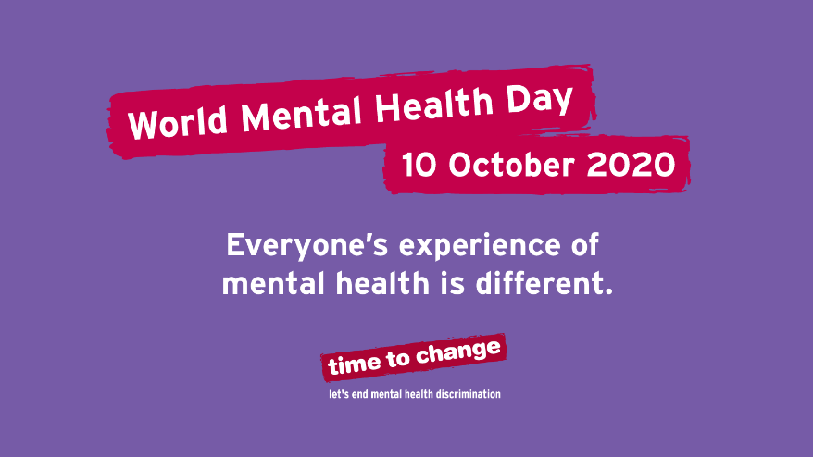
World Mental Health Day is a day for global mental health education, awareness and advocacy against social stigma. It was first celebrated in 1992 at the initiative of the World Federation for Mental Health, a global mental health organisation with members in more than 150 countries. This day, each October, thousands of supporters come to celebrate this annual awareness program to bring attention to mental illness and its major effects on peoples' lives worldwide

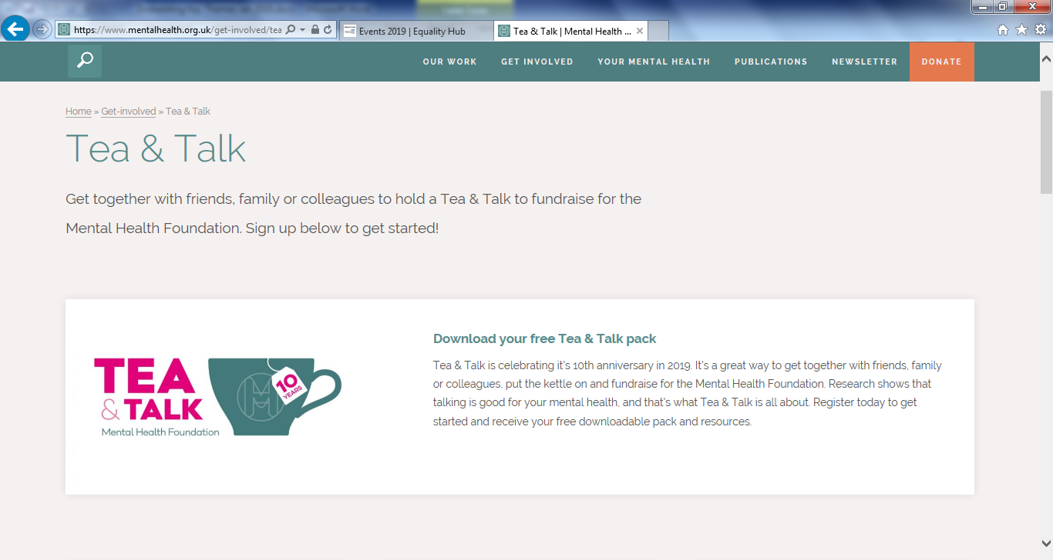
The Mental Health Foundation promote tea and talk sessions https://www.mentalhealth.org.uk/get-involved/tea-and-talk. Although this may not be suitable in terms of social distancing considering COVID-19 you can virtually hang out with friends, family and colleagues by holding a tea and talk to fundraise for the Mental Health Foundation. Over 9 million people in the UK – almost a fifth of the population – say they are always or often lonely, but almost two thirds feel uncomfortable admitting to it. Over half (51%) of all people aged 75 and over live alone.

By taking part in the fundraising for Tea and Talk, or just including your social circle in a virtual catch up you will be acting altruistically. Altruism has been proven to be good for your wellbeing and is defined as caring about other people and/or acting in someone else’s interests. For example, we may be acting altruistically by offering to pick up some shopping for elderly neighbours or by volunteering in our community. Altruism:
- promotes positive physiological changes in the brain associated with happiness
- brings a sense of belonging and reduces isolation
- helps to keep things in perspective
- reduces stress and improves our health
- helps reduce negative feelings
- help us live longer

To find out more about how you can take part in Tea and Talk and further reading on mental health and
services you can access check out these links below:
https://www.mind.org.uk/
https://www.mentalhealth.org.uk/get-involved/tea-and-talk
https://www.nhs.uk/using-the-nhs/nhs-services/mental-health-services/how-to-access-mental-health-services/
You can choose to do any or all the suggested activities below and your tutor will support you with any help you may need:
Question: Can you give examples of altruistic behaviour that could support elderly, isolated people? Click here to enter text.
Question: If there are 9 million people in the UK, and 1/5th say they always or often feel lonely, how would you work out how many people this is? Click here to enter text.

Internet Trolls
The Department for Education and the government have established Key Themes as specific topics that aim to enrich your learning by improving your wider skills and understanding above and beyond the course you are taking. Skills South Tyneside and your training provider want you to gain the most from your programme of learning and these activities will help to embed those Key Themes. The Key Themes are:
M-  Maths | E-  English | ILT- Information Learning Technology | EDI- Equality, Diversity Inclusion | S-  Safeguarding | P- Prevent | C-  Climate | HS- Health and Safety | BV-  British Values

The internet has given us many wonderful things: instant messaging, movies on demand, online gaming and the ability to find out the answer to any quiz question ever…but the internet has also brought new ways of communicating negatively that weren’t possible when memes were delivered by carrier pigeon.

One of the worst is internet trolls. In children’s stories a troll is an angry, anti-social monster hiding under bridges. Instead of under bridges, internet trolls hide behind their computers or phones and go out of their way to cause misery online.
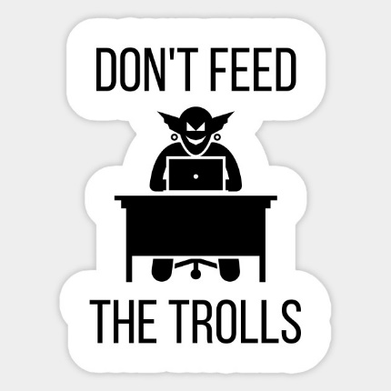
The Centre for Countering Digital Hate have produced a practical guide for public figures dealing with trolls called Don’t Feed the Trolls have said that there are two main types of trolls:

The first type of troll targets public figures with large social media followings in the hope that they respond. The trolls then have their hateful messages re-broadcast to a wider audience when the target of their trolling, or their followers, respond.

The other type of trolls are people who exhibit a psychological trait known as ‘negative social potency’ – this means they enjoy causing harm to others

How does trolling affect people?
It might seem like there are no consequences due to the anonymity that the internet can provide, but there are consequences for the person trolls are targeting, and for themselves. Trolling can cause heightened levels of anxiety, lower self-esteem and have even caused victims to commit suicide.

Can anyone be tempted to troll?
You might be tempted to troll by seeing something or someone you don’t like and be tempted to send an unkind message. A way you can stop yourself is try putting yourself in the person’s shoes that you’re trolling and that may help you think twice about what you post. Remember, there are consequences for trolling too; people have been excluded from school or university, lost their jobs, friends and have even been jailed for sending abuse online. Not only is it a terrible thing to do but it could also risk your own future by engaging in trolling.
Further Reading
https://www.counterhate.co.uk/dont-feed-the-trolls
https://www.gov.uk/government/news/internet-trolls-to-face-2-years-in-prison
You can choose to do any or all the suggested activities below and your tutor will support you with any help you may need:
Question: how did this article make you feel? Click here to enter text.
Question: Which of the British Values does internet trolling fail to comply with? Click here to enter text.
Research Online: Read the article https://www.wired.co.uk/article/online-aggression and consider if you feel people are more aggressive or unpleasant online, and if so, why? Click here to enter text.

