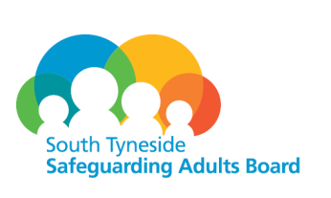
APPENDIX 2
Consideration Request for Safeguarding Adults Review
DATE
Referrers Details
Name
Job Title
Agency
Contact details
Authorised by Senior Manager
Name
Contact details
Details of Concern
Name
Address
Any other known address
Date of Birth
Date of Death (if applicable)
Religion
Ethnicity
Any disabilities
Name and address of GP
Family / Next of Kin / Advocate/ Representative
Name
Contact Details
Agencies involved
Are or were there any legal orders in place? YES / NO
(If yes please identify what they were)

Relationship with Perpetrator (if applicable)
Details of alleged perpetrator/s
Name
Home Address
Any other known address
(please list)
Date of Birth
Religion
Ethnicity
Any Disabilities
Other members of the adult concerned household
Name |  | Date of Birth |  | Address | Relationship to adult concerned
Details of the incident
Agencies involved

SAR Criteria
Please highlight which of the criteria below has been met.
Please put a X in the appropriate box and give a brief summary of your rational.
An adult at risk dies (including death by suicide) and abuse or neglect is known or suspected to be a factor in the death
An adult has sustained a potentially life threatening injury through abuse neglect, serious sexual abuse or sustained serious or permanent impairment and health or development through abuse of neglect; and one of the following
- Where procedures may have failed and he case gives rise to serious concern about the away in which local professionals and/or services worked together to safeguard adults at rick
- Serious or apparently systematic abuse that takes place in an institution or when multiple abusers are involved. Such reviews are likely to be more complex, on a larger scale and my require more time
- Where circumstances give rise to public concern or adverse media interest in relation to an adult/adult at risk
Brief summary of Rationale

N.B. for STSAB Action
Date Received
Learning and Improvement meeting arranged for
SAB Chair notified
Relevant documentation sent out to Learning and Improvement

Please return this form to safeguardingadultsboard@southtyneside.gov.uk within 48 hours of notification.

